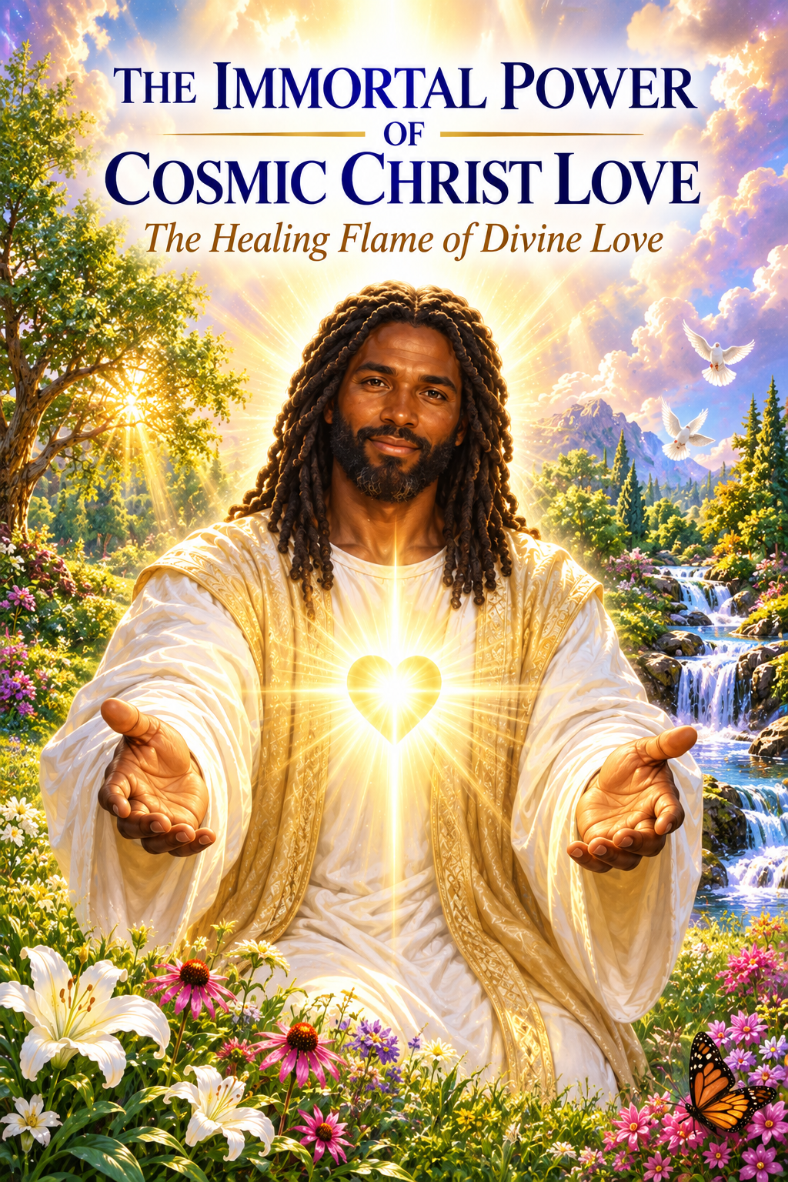

THE IMMORTAL POWER OF
COSMIC CHRIST LOVE
  - Golden Flame of Love
A Spiritual Reading

The Reading
Hi, Maurice, I received your question, so thank you for your payment and hope all is well. I shall begin my prayer of invocation. Father, Mother God, we call forth the highest frequency, the highest light from Maurice's soul growth.
As always, Father, surround us with your love, light, healing, wisdom, and truth as we invoke the energy of Master Joshua to step forward to bring his words of wisdom, healing, and guidance for this beloved soul. And as always, Father, surround us with your Holy Grace. In this, we give our blessings, and so it is.
Greetings, dear one. Yes, it is I, Christ. I come now to tell you, dear son, that the energy of the power of the cosmic Christ love, the immortal power in Immortal Purity is truly a God-given birthright.
It is a part of your original energy as a divine spirit to be infused within your own soul and within your own soul's essence. And so, dear one, as you continue to raise your frequency and to rise in vibration, you will continue to feel the power of this frequency, to begin to feel the power of the immortal light and love that is held within what we call your seed core atom. And so know at this time, dear one, that as you allow yourself to receive this blessing of the grace of the Holy Spirit within you, may it help you to warm your heart and to feel the power within your own soul.
For it is an energy that cannot be qualified, as they say, for it is a limitless supply of energy. And as a conduit of light, as a Christed being, as a messenger of love and peace and hope and renewal, the frequency of this flame, of this what we call the power of the Cosmic Christ Love Flame, shall begin to continue to ignite within you as your heart begins to expand and your light becomes even more powerful. And so, you shall begin to receive these gifts with an open heart.
As you welcome me, Christ, into your heart and ask me daily, I will direct daily to you, into your consciousness, the ideas, the beautiful thought forms from the mind and the heart of the creator that has never been externalized before and which will assist you in embracing and becoming the consciousness of divine cosmic love, allowing the power and the presence of God's living light to be felt upon your soul. And so as you continue to invoke these frequencies within you, may you begin to feel the energy, my beloved victorious “I AM Presence”, light of my soul, my beloved holy Christ self, wisdom of my soul, beloved father mother God from the great central sun, beloved masters of the great white brotherhood, seven mighty archangels and seven Elohim of God. I'm willing to fill my life with the love of God, to fill my heart with the power of the cosmic Christ love, the immortal power and Immortal Purity of the cosmic life.
I'm so longing for grace from the heart of God. I open my heart to thee. I am here to open my divine light, my divine heart to you as I open my heart into devotion.
As I now pour forth my love and devotion onto thee, asking to be restored to my eternal Cosmic Freedom, to be connected truly to the energy of my “I AM Presence”. As I'm renewed in the embrace, I feel the peace of the Eternal Flame of love and the power of the cosmic Christ and the purity of the cosmic love. As you begin to understand this more deeply, you will begin to understand that indeed you are a conduit as you open your heart with purity.
There's nothing more to do except to receive it with intention as you help yourself to understand that this energy truly is the power of God's love held within each one's earth right, held within one's soul, held within one's spirit. We shall begin to feel this connection as it connects to your heart chakra as it begins to magnify the love of the divine and the love of your human self. Love divine qualities continue to build within you of compassion, mercy, charity, and the desire to be God in action to the love of the Holy Spirit.
As you receive this energy upon this day, know that love shall prevail and that you are always in the loving hands of God's love, that you're always in the loving hands of God's love. At each moment that you breathe, each moment you take in, you continue to invoke this frequency and this power within you, that you continue to invoke the energy of the presence of God and your “I AM Presence”. For the presence of God is always waiting for the opportunity to serve through you.
The beautiful, loving, all-powerful Father, Mother God of life stands in a constant attitude of listening. Whenever that frequency is called, whenever you call the name of the God “I AM”, he answers with an outrush of his Mighty Presence that the instruments created and prepared by his love. Because you are love, you dearest ones, dear one, are one of the beloved child or children of the Father, Mother God of life.
And as your eyes open and your ears begin to see, you're going to feel the Presence of the Holy Spirit within your being and allow yourself to feel this Presence, truly of the power, always allowing yourself to receive this most potently and most powerfully. As you become a conscious channel and conduit, become conscious always of your aspiration to embody the full expression of Godhead and devote all of your being in service to that end. Learn the lessons of selflessness either by word, by thought, by deed.
Know that the action that you bring forth in bringing forth your beautiful, merciful heart onto others is felt. Again, this is the Power of the Cosmic Love. As you open your heart to receive the gift of God's Light upon your soul, walk upon the earth plane knowing that you are a vessel of peace, love, and light, keeping yourself in the highest of vibration and letting your heart sing a gratitude and joy unto God.
Be grateful always for all that you've received and that you have in this now moment, what we call the river of life, the river of love and abundance that lies within your sacred heart, your merciful heart, knowing and believing and trusting in the word of gentleness, humility, and loving service. Do not allow yourself to be dissuaded by what you do not understand, but remain fully in the light of God's healing presence upon your soul. As you begin to further your connection to your “I AM Presence”, as you further connect to the energy of this frequency, know that that's what I spoke of and what you are living and being and expressing upon this day is that which I meant to bring forward into my life frame 2,000 years ago.
And as I continue to bring it forth today, knowing that the supreme glory of the hour of light within you is upon you. And then I urge you in this moment to open your heart to the love of God, that you can fulfill your divine purpose in preparing your consciousness to become what we call a Son of Light, freeing yourself truly of any limitations and allowing the Power of the Immortal Power and Immortal Purity of Cosmic Christ Love to fill your heart with love, to fill your heart with Purity, to fill your heart with Peace. Truly, may the love of God surround you.
“Beloved Mighty “I AM” I call upon the Power of the Immortal Power and Immortal Purity of Cosmic Christ Love to fill my heart with love, to fill my heart with Purity, to fill my heart with Peace. Truly, may the love of God surround me.”
The power of God protects you. The presence of God watches over you wherever you are, God is and all as well.
And as you feel this powerful healing energy moving through you, know that your beloved “I AM Presence” and all the Angels, Master Guides and teachers to stand with you are always here helping you now to receive this beautiful gift as I Christ come forth to charge you with this Radiant Healing, the Radiant Healing of Light of the Immortal Power of the Cosmic Light.
As you become fully manifested in that light, truly trusting and knowing that you are here to serve, you're here to love, and you're free to be. That you're here to serve, they're here to love, that you are free to be. And as you invoke this frequency within your essence, know that the love of God surrounds you.
And once again, the power of God protects you. The presence of God watches over you, knowing that you are a conduit of this powerful frequency. As you deepen this understanding within yourself, there will be no more questions.
You will simply feel your spirit rising within you. And then you're holding this frequency within your being so fully, so exponentially, so powerfully, so forcefully that you will never question this again. Truly, truly, truly, you may feel the power of God's living light upon your soul.
Truly, truly, truly, may you feel the power of God's living light upon your soul. Truly, may you feel the power of God's living light upon your soul. As you begin to invoke this energy, in the name of the Beloved “I AM Presence”, I will call the power of divine love to be magnified within my heart and my world daily.
Beloved “I AM Presence”, I will call the Power of Divine Love to be magnified within my heart and my world daily.
I AM Love, joyous love, radiant love, unconditional love. God consumes my shadows, transmuting them into love. This day, I am a focus of Divine Love, flowing through every cell of my being.
I'm a living stream of pure Divine Love that can never be requalified by fear, anger, hatred, dislike, and greed. All negative thoughts and feelings are now dissolved and consumed by the power of Divine Love, which I AM. I AM, I AM, I AM Love.
I live in the Consciousness of Love. I AM Love in its fullest expression, blessing all mankind with Divine Love. I radiate love.
I AM Love in action, blessing, uplifting, and healing me and all on earth. I AM now the representation and the manifestation of the power of the Cosmic Christ Love within the immortality and the power and the purity of my beautiful Cosmic Threefold Flame. I stand forth in the energy of the Christ Light and I am free, I AM free, I AM free. Beloved Great Presence, I AM.
Allow me to feel this glory and allow my heart to open so that I may receive. For in deep gratitude, I offer my gift of love unto You and onto the world. May I feel the presence.
Once again, may I feel the power. May I feel the glory. May I feel the love.
From the Lord God of my being, I am that I am, I decree. I have love for my journey and I have love for all of life and I choose to remain a conduit of pure love and light onto the cosmic flame of the Christ love. In this, I bring myself, as they say, home to thee as I return home to my immortal self and feel the power of the presence of my own light shining forth upon this earth plane.
Know Dearest Ones that you have called and we have come and in this moment of time, it is of great importance, it is a great power, is of great service that you've stepped into the power of the Threefold Flame of the Cosmic Flame of the Cosmic Christ Love, feeling the immortality. This is the true meaning as you begin to embody it, to receive it and again to express it through your vessel as a beautiful conduit of God's Living Light. This is the time, this is the now, this is the moment to receive as you truly understand and deeply understand that you here are by Divine order and that your blessings, your body, your consciousness, your mind and your soul are all receiving this beautiful gift of Great Love, of my Cosmic Love, Cosmic Peace and Cosmic Grace upon your soul.
Go now my child as you prepare yourself to receive, know that you are here by Divine Appointment and that all is as it should be as you allow yourself to receive, as you allow yourself to receive, as you allow yourself to receive. In the name of the Light of God that never fails, accept a Healing Miracle in your life this day as you reclaim again the energy of the Power of the Cosmic Light and the Immortal Power and Immortal Purity of the Cosmic Flame. Know that you are a blazing miracle and this flame is flaming through you, resurrecting you back to the true identity and to God, blaze the Miracles of Light through you.
Beloved I am, beloved I am, beloved I am. Know that you are at peace, that you are a powerful conduit of great consequence and of great service. Go now my child and allow yourself to feel this power and feel the presence upon your own soul of the light of the God that you are.
Live in full expression of the truth of all that you are. Go forward with the understanding that you are now able to walk and to embody and to embrace again all that is yours to receive. And so dear Maurice, may the love of God surround you, the power of God protects you, the presence of God watches over you wherever you are, God is and all is well.
May you once again feel the power and the presence of God's living light upon your soul. In Christ's love, go in peace. THE END

The Healing Flame Takes Command
I say you have but to call It into outer action and Its Manifesting Presence will be there at your Call. And in healing or controlling certain conditions in the physical world, were you to call forth Immortal Master Purity of Cosmic Christ Love and Power, and demand that Power surge there the Eternal Purity of that Love of the Cosmic Christ, then the Healing Flame takes Command and possesses all within Itself. You have been using so-called "outer world" power, and the outer world has used it; and yet all the energy put together of the outer world is naught compared to Cosmic Christ Love. So when you call the Power of Cosmic Christ Love-the Immortal Power and Immortal Purity of Cosmic Christ Love-into everything you do, into all your problems, to dissolve them into Love, you will find Love is your endless, ever-expanding supply of everything, including your money, if that is what is required.
I call forth Immortal Master Purity of Cosmic Christ Love and Power, and I demand that Power surge there the Eternal Purity of that Love of the Cosmic Christ, Healing Flame takes Command and every cell within my body.
So, when you call the Power of Cosmic Christ Love-the Immortal Power and the Immortal Purity of Cosmic Christ Love-into everything you do, into all your problems, to dissolve them into Love,

Invocation of Cosmic Christ Love
I welcome now the radiant, living Light of God upon my soul. In Christ’s Love, I go in peace.
I call forth the Immortal Master Purity of Cosmic Christ Love and Power. I demand that this Power surge into me — the Eternal Purity of that Love of the Cosmic Christ — to flood my entire being with healing.
Let the Healing Flame take full command. Let it flow into every cell, every atom, every tissue within my body — Restoring, purifying, and raising me into perfect wholeness.
I renounce all illusion of outer power. For all the energy of the outer world is but a whisper before the Ocean of Cosmic Christ Love.
And so, I command:
O Flame of Cosmic Christ Love — Immortal Power and Purity — Flow into all I do. Flow into every condition. Flow into every challenge. Dissolve every fear, every burden, every limitation — into Love.
Love is my endless, ever-expanding supply. Love is the answer, the Light, the Healing, and the Provision — In this moment, and in all that is to come.
I AM the Resurrection and the Life of Cosmic Christ Love made manifest now. I AM the Flame, I AM the Power, I AM the Peace.
And so it is.
Amen.

