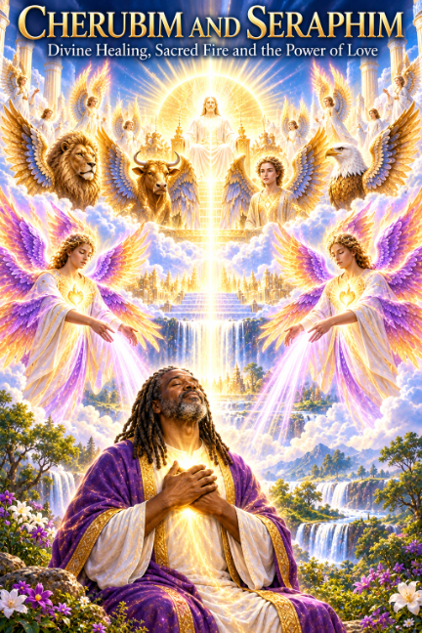
The Seraphim Angels and the Sacred Fire
A Spiritual Journal Reading from August 13, 2022
As I return to this reading from August 13, 2022, I can see more clearly how many of the teachings that were given to me then have continued to unfold throughout my spiritual journey. The Seraphim Angels, Divine Love, the Sacred Fire, the Resurrection Flame, my Mighty “I AM Presence,” the Divine blueprint, and the simple practice of breathing into my heart all appear in this reading. Looking back now, I can see these teachings as connected parts of a path that has continued to deepen over the years.
The reading began with a call to the highest Light and the presence of Archangel Michael, Master Joshua, the Seraphim Angels, and the Beloved Masters. I was reminded of the importance of receiving care, family support, and love. From there, the message moved directly into the healing work of the Seraphim Angels and the Sacred Fire.
The Seraphim Angels and Healing
I was encouraged to call upon the Seraphim Angels for healing and to work with them daily. The reading described them as mighty healing Angels whose Sacred Fire could be called upon for purification and renewal of the mind, body, spirit, and emotions. I was asked to open my heart and mind to receive this energy of Love and to allow their healing presence to assist me as I moved forward on my spiritual mission.
What is important to me today is the repeated invitation to participate consciously in the healing process. I was not simply told to wait for something outside of myself. I was instructed to call, breathe, receive, visualize, affirm, and open my heart. That same active relationship with Divine Light remains an important part of my practice today.
Divine Love Through My “I AM Presence”
The reading then turned to Divine Love. In the name of my beloved “I AM Presence,” I was taught to call the Power of Divine Love to be magnified within my heart and world daily. The words declared, “I AM Love,” and described Divine Love flowing through every cell of my being, dissolving fear, anger, hatred, negative thoughts, and feelings and replacing them with the consciousness of Love.
This teaching has stayed with me because Love was presented as more than an emotion. Love was something to embody and radiate: “I AM Love in action, blessing, uplifting, and healing me on all levels.” As I read those words again today, they connect directly with something I have come to understand more deeply in my journey: Love is the healer, and Love heals all that it touches.
The Flame of Purity and the Divine Blueprint
Another important part of the reading was the call to the Cosmic Purity Flame. I was encouraged to invoke Purity into my thoughts, feelings, body, mind, Soul, and Spirit, releasing discordant energy and allowing the fullness of the Mind of Christ to manifest within me. The reading connected this Purity with the Resurrection and Ascension Flames and with the restoration of the Divine blueprint.
The words that stand out to me are the call to awaken the remembrance of my Divine blueprint through the Love of Christ and the Resurrection Flame. I was affirming: “I AM Purity in action,” and asking that every cell, fiber, and part of my being be filled with Sacred Fire, Love, Purity, Beauty, and Divine Perfection.
The Resurrection Flame Was Already Part of the Journey
When I read this old message now, I am especially moved by how clearly the Resurrection Flame was already present. I was given the affirmations: “I AM the Resurrection, the Life of my perfect health. I AM the Resurrection, the Life of my eternal youth and beauty. I AM the Resurrection, the Life of my beautiful Heart Flame. I AM the Resurrection, the Life of My Divine Matrix.”
Today the Resurrection Flame has become an even more important part of my spiritual practice. Looking back four years, I can see that this was not something that suddenly entered my life. The teaching was already being given to me, and over time I continued to grow into it and understand it in a deeper way.
Calling Forth the Miracle Light
The reading continued by calling upon the Resurrection Flame of Christ energy and the Miracle Light of God. I called upon Master Jesus, the Holy Spirit, and the Light within my heart, chakras, physical body, and DNA. I declared myself a miracle of God and called for restoration of my physical, mental, emotional, and etheric bodies to the true identity and Divine blueprint held within my God Essence.
This section was not merely about asking for a miracle. It repeatedly brought the focus back to Love, Light, Divine identity, and the Christ Presence within. I was calling forth healing while also affirming that God’s Healing Light was flowing through me and that the Master Presence was charging my bodies with Love.
The Green Flame of Healing and the Christ Presence
The reading also spoke of the Healing Flame appearing Green and called upon the Seraphim Angels and the Masters to bring healing on all levels. I asked that the physical, mental, emotional, etheric, and subtle Light bodies be charged with Love, and that the Christ Presence within me radiate Healing Light.
Again and again, the message returned to receiving, clearing, healing, and allowing Divine Perfection to become active within my consciousness. The Seraphim energies and the Beings of Light were called upon to assist while I consciously opened myself to receive the Healing Ray.
Surrender Into Divine Love
Later in the reading came a prayer of surrender. I called upon Father-Mother God and surrendered my being into Divine hands so that all that hindered the fulfillment of my Holy Purpose could be released. The message then became very simple: feel the Love, feel the Power, feel the Presence. Wherever God is, all is well.
This part reminds me that spiritual practice is not only about commanding or invoking energy. There is also a time to surrender, to trust, to receive, and to allow the Love and Presence of God to wash over the Soul.
My Hands Over My Heart
One of the most meaningful passages for me today is the instruction that followed: “Breathe into your heart, placing your hands over your heart, breathing deeply into your heart.” I was asked to visualize myself in Divine Holy Perfection, set the intention to heal, and recognize the Angels, Divine Masters, and Seraphim Angels gathered around me.
Then I was instructed to breathe into my “I AM Presence,” allowing its incredible Light to grow brighter and brighter until it covered my entire body. I was asked to imagine a Golden Light reaching upward and connecting with the Universal Life Force.
When I read this today, I recognize something that has become part of my present practice. I place my hands over my heart. I breathe into my Heart Flame. I call upon my Mighty “I AM Presence.” I become still and allow myself to receive. What was being taught to me in 2022 continued to unfold in my life.
“I AM the Light”
The reading then brought me into a series of affirmations that remain powerful to me: “I AM one with the Light. I AM whole. I AM perfect. I AM Divine. I AM one with Divine Intelligence. I AM one with infinite possibility. I AM guided by the Light. I AM the Light.”
It concluded this portion with “I AM That I AM” and the declaration “I AM the Light” repeated again and again. The message was leading me toward recognizing the Holy Essence of God’s Light within, not merely looking for Light outside of myself.
Another affirmation said, “I AM ready to embark upon a spiritual journey of healing. I AM ready to deepen my awareness and heighten my spiritual connection.” Looking back from where I am today, those words carry a special meaning. The journey did continue.
The Seraphim Prayer That Grew from the Reading
After the original reading, I wrote affirmations and prayers of my own based upon what I had received. I called upon the Seraphim Angels and the higher vibration of the White Light of God, breathing in their vibration and asking their Sacred Fire to purify and renew my energy.
I called upon the Great Spirit of Love within my heart, my Mighty “I AM,” Beloved Master Jesus, and the Seraphim Angels to release the mighty healing current of Sacred Fire. I asked that all distortions in my physical, emotional, mental, and energetic fields be purified and transmuted into the Living Light of God.
These prayers show me something important about my journey. I did not simply receive the reading and put it away. I began working with what I had been given. I turned the teaching into prayer, invocation, breath, affirmation, and daily spiritual practice.
Looking Back, I Can See the Path
When I look back at this reading now, I see a pattern that I could not have fully understood at the time. The Seraphim Angels. The Sacred Fire. Divine Love. The Flame of Purity. The Resurrection Flame. The Christ Presence. The Mighty “I AM Presence.” The Divine blueprint. The Heart Flame. The breath. The hands over my heart. These were not isolated teachings. They became threads woven through my spiritual journey.
I continue to learn that a spiritual teaching may enter our lives long before we understand how deeply it will become part of us. Sometimes we must live with it, practice it, leave it for a while, return to it, and then discover that it has quietly been preparing us for another stage of the journey.
This old reading reminds me that my path has been unfolding step by step. I continue to learn. I continue to practice. I continue to go deeper within my heart. And I continue to call upon Divine Love, the Sacred Fire, the Resurrection Flame, and my Mighty “I AM Presence” as living parts of my spiritual journey.
The words given to me in 2022 still speak to me today: “I AM ready to embark upon a spiritual journey of healing. I AM ready to deepen my awareness and heighten my spiritual connection.” Today I can look back and say: the journey continued.

