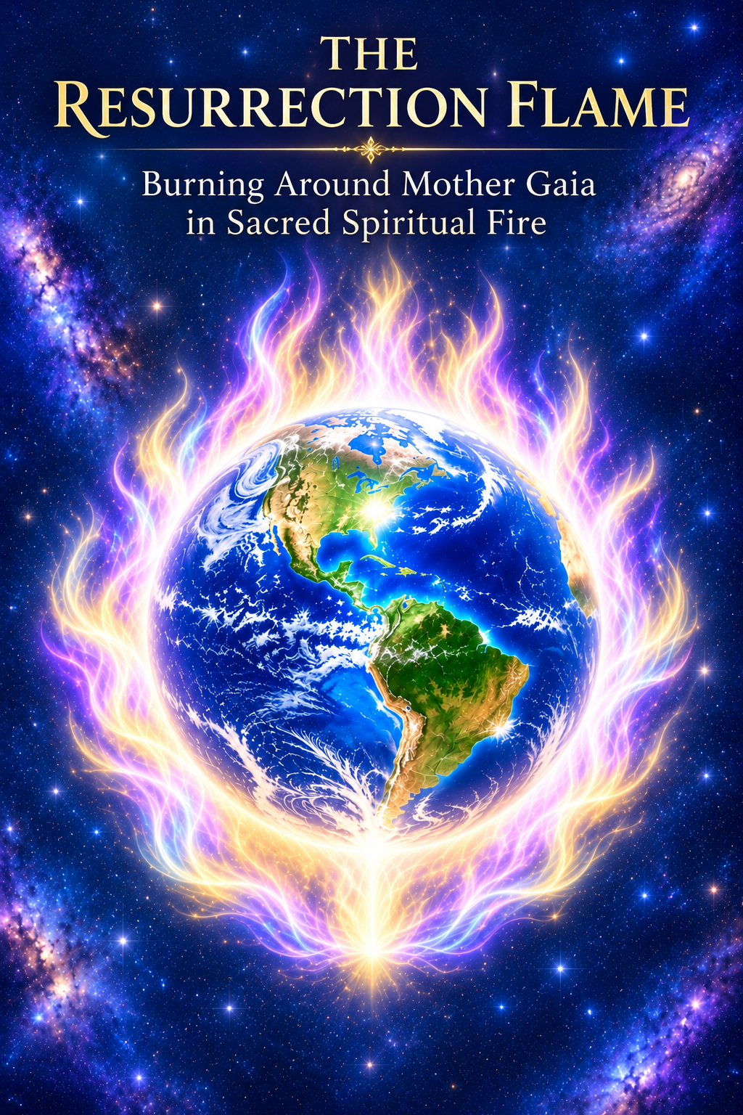

Tune into Resurrection Flame
Maurice, feel and tune into the Resurrection Flame burning within your heart. As you declare: “I AM the Resurrection and the Life!” Feel the absolute truth of this statement resonating through your entire being. Imagine this Golden, Violet, and Pink Flame expanding from your heart chakra, enveloping your entire body in its Sacred Fire. Now, see the Resurrection Flame growing even stronger—expanding beyond your form, filling the room, igniting with Divine Power—not in a physical sense, but as a force of transmutation. It dissolves all negativity into the Flame of Christ Light, restoring perfection, balance, and Divine harmony. Christ Himself used this Flame in this way, and so can you, now. Allow it to build within you and radiate outward, blessing the world.
Tune into the true message of Christ Light, of Compassion for all, Connection to all, Love for all in the NOW, in every now. See the Resurrection Light growing within you, expanding beyond your being, wrapping around the entire planet. Humanity is lifted, elevated to a new level of Divine Consciousness. As you practice this sacred visualization, recognize your ability to manifest miraculous healings—both in your life and in the lives of others.
Maurice, allow the Resurrection Flame, the Flame of Hope, Love, Compassion, and Christ’s Tranquility, to burn within you. Allow your Innate Intelligence to align with this Light, directing its wisdom and power for restoration and divine purpose. Now, let your inner light and divine power flow forth. See the entire world ablaze—not in physical fire, but in the Flame of Christ, purifying, transforming, and illuminating all life in its perfect divine blueprint.
Look to the life of Christ, who walked before you. His message was one of activated Inner Light, Resurrection Light, and Divine Power. To fully experience life’s grand design and beauty, and to truly experience God as the living, conscious force connecting all, embrace this Light. Know this truth: It is not outside of you—it is within you. It is activated and burns brightly as the Resurrection Flame within you! So be it. It is done
Use the Resurrection Flame
"I send my love to my Beloved ‘Mighty I AM Presence’ to come forth into action. My Beloved ‘I AM Presence’ comes forth into action with the Power of the Resurrection Flame, to resurrect the Sacred Fire within my Heart. Beloved Innate, the Divine Intelligence of my being, I call upon you now. Align fully with my Mighty I AM Presence and the Power of the Resurrection Flame. Receive and integrate this Sacred Fire, resurrecting my entire being into Divine Perfection. Activate the blueprint of my perfect health, restore every cell, organ, and system, and reveal the wholeness that is already mine in the Mind of God!"
I AM the Resurrection Flame and the Life, bringing forth the Power of Now, and the frequency of Elohim Grace to resurrect my body to perfect health and wholeness now made manifest. Beloved, my Mighty ‘I AM Presence,’ this body is Yours; these eyes belong to You, these ears and these senses belong to You. Beloved ‘I AM,’ with the Power of the Resurrection Flame! I ask my ‘I AM Presence’ to resurrect this beautiful body, to perfect health, wholeness, and vitality."
I AM the Presence, Love fulfilling my commands, and I AM calling You forth! My Beloved ‘I AM,’ with the frequency of Elohim Grace and the Power of the Resurrection Flame, we begin now! Come forth into action within this body; resurrect this body into perfect physical health and wholeness! Charge my mind and body with Your strength, Your power, Your beauty, and make this Temple the most beautiful, youthful Temple that honors You, my Beloved ‘I AM Presence.’"
My Beloved ‘I AM,’ with the Power of the Resurrection Flame and the frequency of Elohim Grace, charge my sight back to perfect vision; strengthen my back—rebuild, reconstruct, and restore the Liquid Light in my knees, joints, and entire body. Beloved Innate, hear this command! Recognize and integrate this Divine Perfection. Resurrect my body, my mind, my emotions, and all aspects of my being to their perfect original blueprint. Let the Sacred Flames restore every system to wholeness!"
I AM the Resurrection Flame and the Life, restoring my body to perfect health and wholeness on all levels of my being.
"I AM the Resurrection and the Life” of my eternal freedom in the light.
“I AM the Resurrection and the Life” of my physical body's perfect blueprint.
“I AM the Resurrection and the Life” of my emotional body's perfect blueprint.
“I AM the Resurrection and the Life” of my mental body's perfect blueprint.
“I AM the Resurrection and the Life” of my etheric body's perfect blueprint.
“I AM the Resurrection and the Life” of my spiritual body's perfect blueprint.
“I AM the Resurrection and the Life” of the Ascended Master's Purity and Love.
“I AM the Resurrection and the Life” of the Healing Powers of the Sacred Flames.
“I AM the Resurrection and the Life” of my Immortal Perfection and the Illumined Love of the Cosmic Christ.
“I AM the Resurrection and the Life” of the Powers of the Sacred Fire within me, restoring all the wonderful gifts of my Divine Essence.
And so it is. I seal it with: “Thy Will be done. Almighty I AM.”

