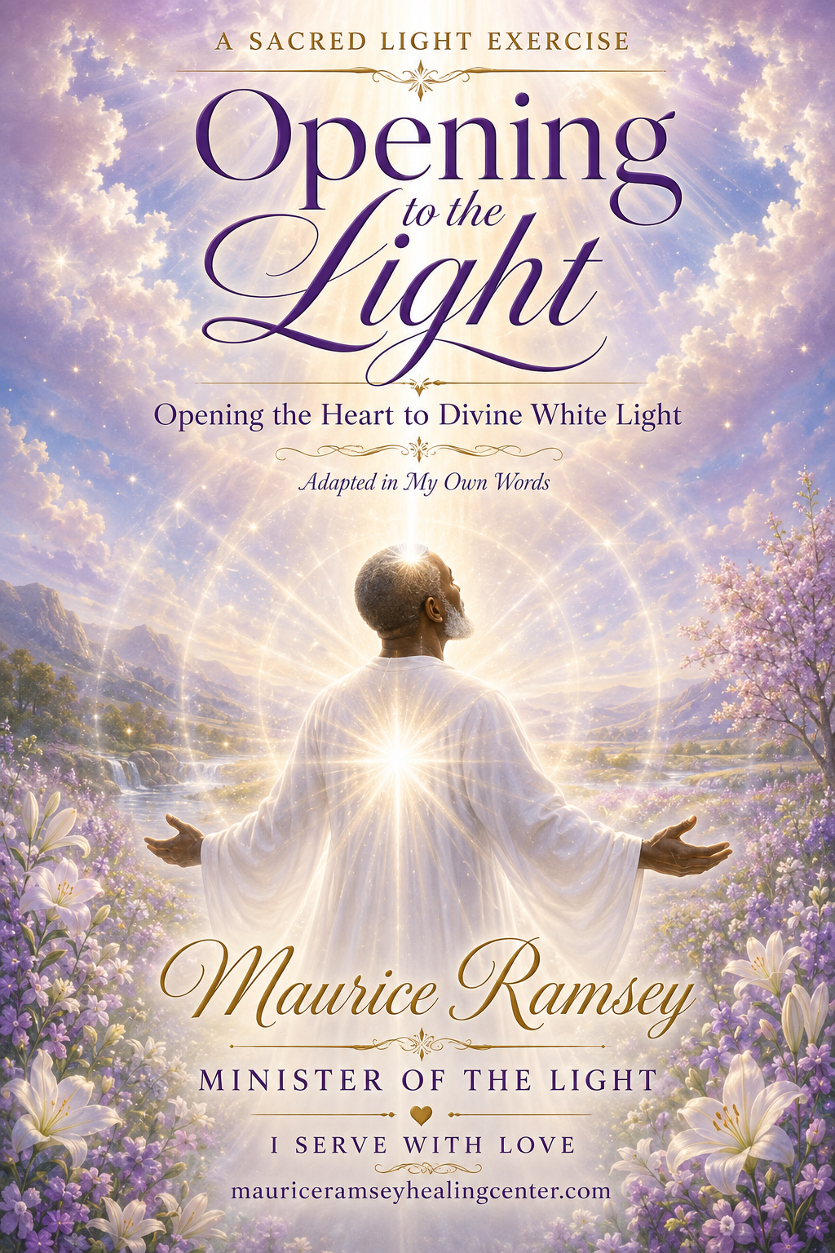

A SACRED LIGHT EXERCISE
Opening to the Light
Opening the Heart to Divine White Light
Adapted in My Own Words
Maurice Ramsey
Minister of the Light
I Serve With Love
mauriceramseyhealingcenter.com

A Personal Word from Maurice
This exercise was given to me many years ago—perhaps ten or fifteen years ago. Its message has remained within my heart because it teaches a simple truth: when we become still, breathe into the heart, and open ourselves to the Light, we remember that Divine Love has always surrounded us.
I now share this exercise in my own words, from my heart to yours. May it help you feel the White Light of God, receive the peace of the higher realms, and remember the Divine Love that lives within you and all around you.
The Light of God surrounds me.
The Love of God lives within me.

Before You Begin
Sit quietly or rest comfortably. Allow your body to relax and open your heart. You do not have to force any feeling; just relax and be open. Simply open your heart and become still; breathe gently into your heart and remain open. Whatever you experience is right for you.
You may read this exercise slowly, record it in your own voice, or have someone read it to you. Return to it whenever you wish to feel peaceful, lifted, protected, and connected with the Light.
Breathe. Be still. Open your heart.

Opening the Heart
Take a slow, deep breath. As you breathe in, bring your conscious awareness inward and focus upon the center of your heart. Breathe gently into your heart and allow it to open.
Your heart is a powerful center of giving and receiving. Through your open heart, you are able to feel Divine Love, receive the consciousness of Light, and send that Light out into the world.
Continue breathing deeply. Allow your mind to become still and calm. If thoughts or doubts arise, do not struggle with them. Simply release them and return to the silence within your heart.

Allowing the Light to Surround You
Now call upon the consciousness of Divine Light to surround you. Know that the Light is present, even before you feel it. Be open and allow the experience to unfold in its own way.
You may feel warmth, tingling, peace, lightness, or a gentle lifting within you. You may see the Light, hear its vibration, sense its presence, or simply know that it is there. If you do not feel anything at first, let that be all right. Keep breathing, keep opening your heart, and keep looking within. The Light still surrounds you.

Releasing All That Is Not Light
As the Divine Light surrounds you, allow it to dissolve any negativity that may have been absorbed into your aura, your energetic fields, or your physical body. Do not hold on to it. Let everything that is not of Love be released and dissolved into the Light.
Breathe in once more. Open your heart and feel the Love energy around you. This is the energy of Light, lifting your vibration and opening you to Love, peace, and the higher realms.

Receiving the White Light of God
Breathe in the White Light of God’s Essence. See and feel the Light pouring into your physical body through the top of your head and your crown chakra. Allow a column of pure White Light to fill your spinal column.
Let this Light flow through every chakra and every meridian. Let it fill every cell, atom, and electron of your body with Divine Light and Love. Feel the warmth, the tingling, the peace, and the healing presence of God moving through your entire being.
The Light swirls around you and expands within you. It cleanses, heals, lifts, and protects you. It raises your vibration so that you may experience the frequency of Light while you are living here upon the Earth.
I breathe the White Light of God’s Essence into my heart.
I AM surrounded, filled, protected, and lifted by Divine Light.

Feeling the Light
It is through your inner feeling that you begin to experience the Light. As you open your feeling centers, you may see the Light surrounding you, hear the gentle vibration of Light, sense its presence, or simply know that it is there.
Do not judge your experience or compare it with anyone else’s. Continue to breathe, open your heart, and allow the Light to reveal itself to you in the way that is right for you.

The Gifts of Light
White Light carries the vibrations of joy, peace, compassion, happiness, and Love. As you consciously fill yourself with Light, these qualities become more natural within your thoughts, feelings, words, and actions.
As you release what is not Light and replace it with Love, light-filled thoughts begin to rise from within you. You open your heart to receive even more of the Divine Presence.

Remembering Your True Nature
Light is your true nature. You are a Divine Soul, a Being of Light. Your spiritual nature exists beyond the limitations of the physical world, and through this exercise you begin to remember how to feel and experience that truth.
Feel the vibration of Light within you. Open your heart to its compassion and Love. As you receive more Light, Love and compassion once again become the natural expression of who you are.
I AM one with my Divine Soul Light Body,
and my Divine Soul Light Body is one with me.

Living in the Light
Open yourself to the Light each day. Breathe, look within, and open your heart, your mind, and your inner senses. As you experience the Light, its blessings begin to manifest in your life.
You are Light-filled. You are abundant. You are loving. You are joy. Breathe in the White Light and know that you are protected and lifted into the consciousness of Love.

Closing in Divine Love
Feel your energy expand. Feel your heart open. Feel your connection with God, with the Light, and with all that is. Know that you are deeply loved by your guides, angels, and the Divine Consciousness of Light.
Invite the Light into your heart. Experience it. Feel it. Return to this sacred place often, for each time you do, you remember more clearly the Light that you truly are.
I AM Light. I AM Love. I AM Peace.
I AM One with the Divine Presence of God within me.
And so it is. Thy Will Be Done.
With Divine Love,
Maurice Ramsey
Minister of the Light • I Serve With Love
mauriceramseyhealingcenter.com

