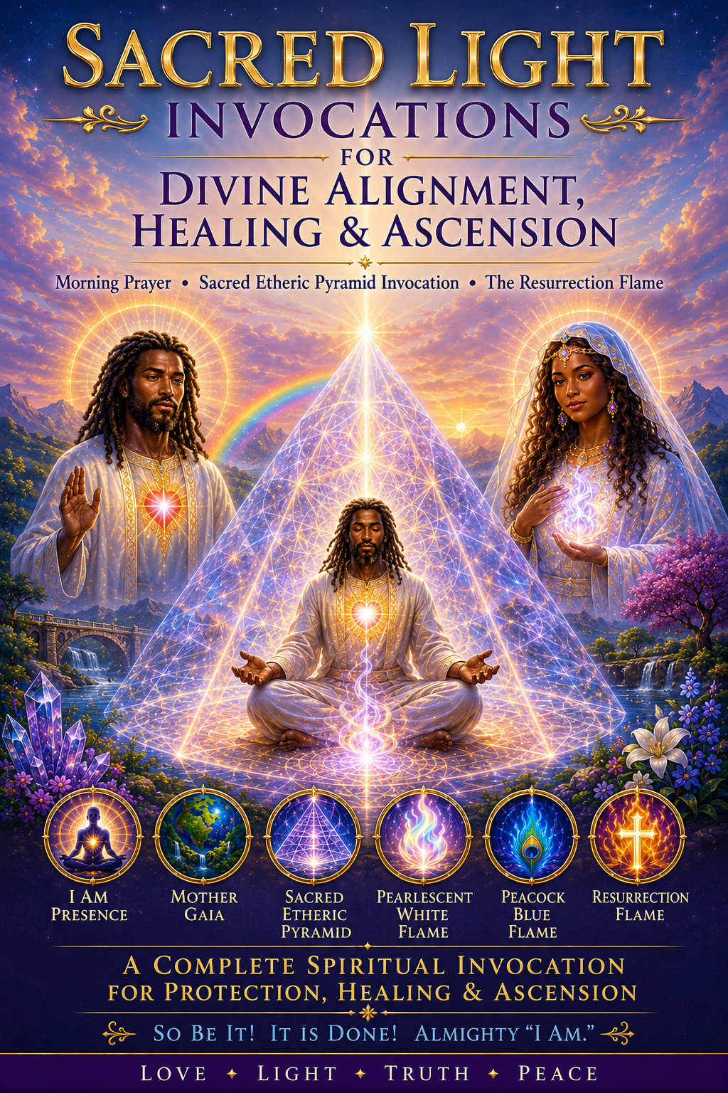
Before Spiritual work or any healing work begins, I enter into the Sacred Etheric Pyramid through this invocation, aligning myself with the Mighty “I AM Presence,” Mother Gaia, and the Pearlescent White Flame of Ascended Master Sarah.

In the Morning Prayer
“I AM One with my Glorious Mighty “I AM Presence,” my Holy Christ Self, my personalities, and my Body Elemental. All parts of my being are now in perfect balance, harmony, and Divine alignment. “I AM” fully contained within my Pearlescent White Flame, purifying everything in my world this day.
I ask that all information and energy exchanged here today be according to Holy God’s Will. I stand in the fullness of His Divine Light.
I open my heart and send my love forth to my Mighty “I AM Presence,” merging in perfect unity with my Holy Christ Self. We are One — moving, breathing, and creating in the Love of the Creator.
I now ground my Christ Light deep within the Crystalline Core of Mother Gaia, anchoring myself within the Heart of Her Divine Presence. I feel Mother Gaia’s Sacred energy rise up around me, igniting the energy of the Spirit of the Earth around me.
My Christ Light now cleanses my being, opening my chakras, restoring, balance, and awakening the Sacred flow of Life within me.
“I AM” the Presence of God blazing the Sacred Etheric Pyramid around me!
O Sacred Fire, rise within and around me, transmuting, dissolving, and consuming all discord, all limitation, and all that is not of the Peacock Blue Flame. The Peacock Blue Flame now purifies my mind, my heart, my body, and my soul. “I AM” made new in the Light of God!
I feel the White Light of Mother Gaia embracing me, lifting my spirit higher and higher, carrying me into the Seventh Realm of Creation, where “I AM” One with God, my Heavenly Father.
I breathe deeply and enter the Seventh Plane of Divine Creation, where only Perfection, Love, and Truth exist. “I AM” not separate from God. “I AM” One with God.
I feel my being merging completely, with the Divine Source. The healing energy of God now flows through my Christ Self, that “I AM,” descending as a radiant river of Light, pouring through my chakras, expanding my heart, and filling my entire being with the Power of Heaven itself.
So be it! It is done! Almighty “I AM.”

The Healing Power of Sarah's Pearlescent White Flame
We all are powerful healers. We must feel this truth within our hearts, allowing our own Light Body to emit powerful frequencies of Divine Energy to assist in the healing and restoration of our physical, emotional, mental, and spiritual bodies.
My Brothers and Sisters, as you fully immerse yourself in the energy of the White Light of God, I always say:
"Breathe in the energy of the White Light of God."
"Breathe in the energy of the White Light of God."
"Breathe in the energy of the White Light of God."
As you do this, you may begin to feel a tingling sensation within your Heart Flame. This is the healing energy of Divine Love flowing through you. You are a powerful conduit and transmitter of God's healing energy.
What you can do is bring the Light of God's Essence through your being so that you may send the healing energy of the White Light of God to your loved ones or to others who are in need of healing, allowing them to receive the energy etherically and allowing their bodies to be restored to greater harmony, balance, and wholeness.
So allow yourself to feel this new energy. Come into the awareness of the power of this Divine Presence upon your soul. As you begin to feel the frequency of God's White Light, you may also begin to feel the loving presence of Sarah's Pearlescent White Flame. Allow the Pearlescent White Flame to flow through your being, bringing Love, Peace, Purity, Innocence, Restoration, and Healing to every cell, atom, and electron of your body.
As you continue to breathe in this Sacred Flame, know that you are not separate from God's healing power. You are a living expression of that power. Allow the Pearlescent White Flame to expand within your Heart Flame, radiating outward into your entire being and into the world around you. And so it is.

Prayer for Healing Cancer & Manifesting Divine Restoration
For the healing of cancer, the annihilation of all cancer cells, and the restoration of perfect health in the beloved name of Jesus Christ.
Beloved Lord Jesus, Beloved Lord Sarah’s daughter of Christ. Divine Healers, and the Sacred Light of Creation,
I call upon Your infinite mercy and power to heal all who are in need of restoration. I invoke the sacred energies of Sarah's Pearlescent White Flame and the Sevenfold Flame to purify my body, soul, and spirit, dissolving all cancer cells within me.
With the power of the Three Times Three Healing Activation, I command that all malignant growths, imbalances, and misalignments be wiped away from the deepest levels of my being. I ask that these cells be replaced with perfect Divine Order and perfect health. May the energy of the Pearlescent White Flame flood my body and restore every cell to its highest Divine Blueprint.
I call upon the Healing Ray of Lord Sarah to surround me with Her Love, Compassion, and Grace. In Her precious name, I declare that every cell in my body is aligned with the Divine Frequency of health and wholeness.
Cancer, you have no place within me—be gone now, in the name of Jesus Christ, in the name of Jesus Christ, in the name of Jesus Christ.
I AM healed, I AM whole, I AM restored.
I trust in the Divine Power to manifest perfect health and well-being, knowing that with each breath I draw closer to my full healing.
I AM Whole, I AM Free from Cancer, I AM Restored by Divine Will, It is done. It is sealed. In the name of God, Thy Will be done.

Sacred Etheric Pyramid Invocation
“I AM” one with my Mighty “I AM Presence,” “I AM” one with my Holy Christ Self.
We exist and work as One upon the Earth, united in the Love of the Creator Source. All of my personalities, my Body Elemental, and my new spirit — all parts of my being — are now in balance, harmony, and Divine alignment.
I now ground my Earth Star into the Crystalline Core of Mother Gaia. I feel my energy ignite with the Spirit of Mother Gaia. I feel Mother Gaia’s Light and Her Love surge upward into my Heart Flame, lifting me in Spirit and surrounding me in an Invincible Tube of White Light.
Opening, all of my chakras energetically. They are now fully open and spinning in perfect harmony. I now pull in my aura, and “I AM” fully contained within my Sacred Etheric Pyramid of Divine Perfection.
Ascended Master Sarah, fill me with your Pearlescent White Flame of Purity and Innocent Love. Fill every cell, every fiber, and every pore of my being, and let it overflow throughout my body and aura field.
I ask my Heavenly Father, let all information and energy exchanged here today be in according of Your Holy Will. And I seal this with: Beloved “I AM,” Beloved “I AM,” Beloved “I AM.”

Before I Lay My Body to Rest!
As I prepare for sleep, I open my heart to the Pearlescent White Flame of Purity, Innocence, Peace, and Divine Love.
Surround me now in your sacred light. Fill my body, mind, emotions, and soul with the gentle radiance of the Pearlescent White Flame. Let all discord dissolve into Peace, all fear dissolve into Love, and all separation return to Divine Oneness.
I call forth the Silver Ray of Light to surround and protect me throughout this night. May only those energies, teachings, and experiences that are according to Divine Will enter my consciousness.
As I sleep, may I be guided to the sacred realms of Light most appropriate for my soul's growth. May I receive the wisdom, healing, and blessings that serve my highest good.
Beloved Sarah, help me awaken more fully to the balance of the Divine Feminine and Divine Masculine within my being. May my heart remain open to the Love of Father-Mother God.
I rest now in Divine Peace, Divine Protection, and Divine Love. And I seal all my being within the Great Pyramid of Power and Divine Protection.
And so it is, ‘Almighty I AM,’ Amen and Amen.

The Resurrection Flame
“I call in Master Jesus’ energy and the higher vibrational frequency of the White Light of God. I invoke Master Jesus’ vibration into my auric field and allow my Higher Self to begin merging with the essence of Master Jesus.
As I open my heart and tune into the Resurrection Flame, I feel this Light of transmutation and Divine transformation burning brightly within my Heart Flame.
When I make the statement, ‘I AM the Resurrection Flame and the Life,’ I feel the truth of these sacred words flowing throughout my whole being.
I feel the Golden Flame burning brightly within my heart, creating a vortex of swirling energies radiating in a clockwise direction around me, transmuting all negativity into the Sacred Fire of the Resurrection Flame, fully restoring my body, mind, and soul into perfect health, balance, and wholeness throughout my entire being.”

A note to the Reader:
I also want to remind the reader, these transmissions, to ask Ascended Master Sarah, to take you to her Sacred Etheric Pyramid it serves as a high-vibrational energy amplifier
I suggested asking to be transported there each night before falling asleep so the tutoring and healing could continue during the sleep state.

