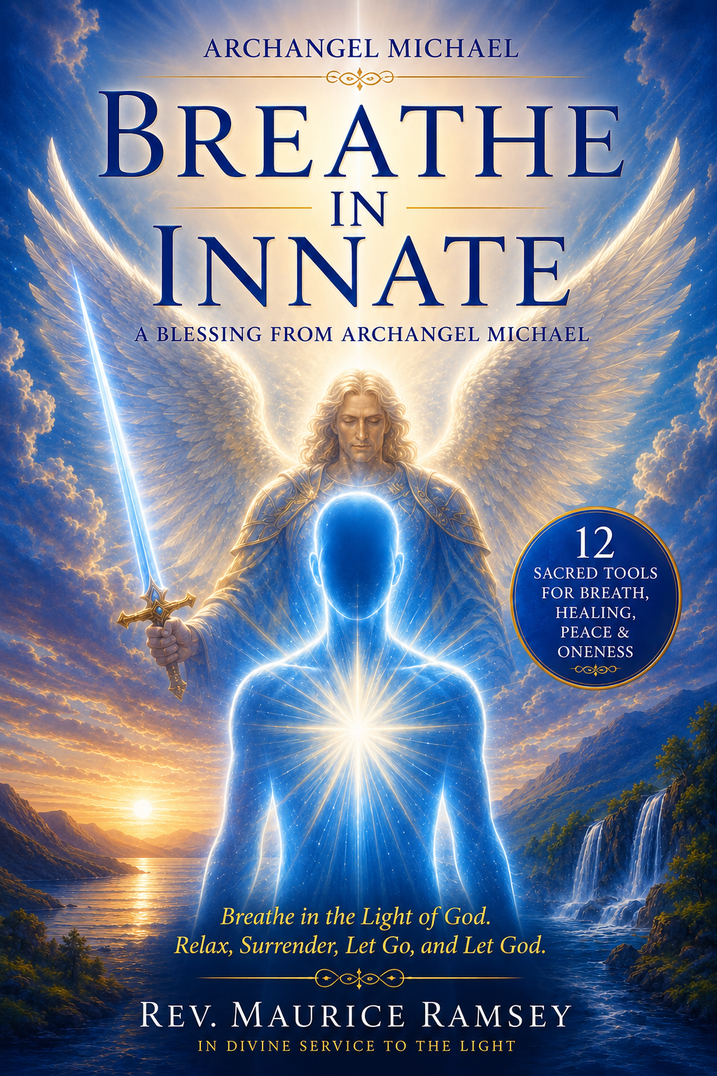
Table of Contents
Acknowledgments & Gratitude 4
About This Book 6
Title Page 7
Dedication 8
The Breath of Life Practice 9
The Meaning of the Breath 9
Sacred Practice 9
2. Breathe the White Light of God 9
Feel your body expand with Light. Repeat softly: 9
4. Awaken the Heart Diamond 10
Affirmation of Unity 10
Opening Blessing 11
Archangel Michael - Joshua 12
First Tool – The Breath of Life 14
Second Tool – Opening the Third Eye 16
Third Tool – Opening the Sacred Heart 18
Fourth Tool – Breathing into the High Heart 20
Fifth Tool – The Sacred Belly 22
Sixth Tool – Awakening the Sacral 24
Seventh Tool – The Sacred Star Point 26
Eighth Tool – The Earth Star 28
Ninth Tool – The Divine Mother Portal 30
Tenth Tool – The Portal of Peace 32
Eleventh Tool – The Silver Ray 34
Twelfth Tool – The Energy of Oneness 36
Closing Blessing 38

Acknowledgments & Gratitude
Transmitted through Rev. Maurice Ramsey, in divine service to the Light.
Archangel Michael – Breathe in Innate
And so, it is of grave importance that you begin to breathe in the energy of the White Light of God and to breathe in the vibration of peace and simply begin to breathe in the vibration of love. And so I ask you to take a deep, deep, deep, deep inhaling breath and simply begin to breathe, breathe Dear One breathe, breathe Dear One breathe, breathe Dear One breathe, breathe in the energy of the White Light of God, breathing the energy of Peace, breathing in the energy of Tranquility, and breathing in the energy of Love. And so Dear One, know at this time that the importance of your breath will help you to align to the energy of Peace. This will help you to align to the vibration of that which you tap into, which is your own Innate Wisdom.
And so Dear One allow yourself to open and receive this healing today from our beloved Joshua . Greetings, it is I, Joshua as I enter into your vibration, I bow to you. I ask you to hold your frequency and vibration to the highest level you are possibly able to embody, with a new energy of this powerful paradigm shift you are now living as a Sacred being. The energy of Mother Earth has shifted so beautifully, so powerfully, and so exponentially that you have grown and expanded more than you can truly understand.
Today I will help you to begin to breathe in the vibration of Love and Joy and to live in the truth and the essence of Love, as we move through these Twelve Jewels of Enlightenment.
First Tool
We will begin with the First Tool which is the Breath of Life, the beautiful energy and essence of the Breath of Life connects you instantly to the Seventh Dimensional frequency. So I ask you to take a deep inhaling breath and begin to allow your body to expand and to breathe, breathing in the breath of life and holding the essence and the power of this beautiful Life Force Energy of your breath with the energy of God. As you hold this frequency of the Vital Life Force of the God essence within your breath we ask you to begin to relax, surrender, let go, and let God.
It is unfortunate that many, including yourself, are unable to tap into their own breath. For as you begin to breathe, allow yourself to connect to your Innate Wisdom and to your Higher Self. When you fully breathe you align yourself to your Higher Self and to the power of the God essence, and so breathe Dear One, breathe, breathe in the Life-Force of your own energy, breathe in the Life-Force of God, simply begin to breathe.
Second Tool
The Second Tool is opening up your Third Eye and allowing yourself to move into a state of awareness. Focus your attention on your Third Eye. God has gifted you with this beautiful energy of sight, of clairvoyance. It is there between your brow that your Third Eye resides; it is connected to your Pineal Gland where all the ancient wisdom teachings are held, where all of your Innate Wisdom is held. So breathe into your Pineal Gland, breathe into your Third Eye; this is how you connect to your Innate Wisdom. It is connected by your breath—all that you’ve ever been and all that you shall ever become is held in the Pineal Gland.

About This Book
This book, Archangel Michael and Joshua – The Twelve Sacred Tools of Breath and Innate Wisdom, is a divine transmission given through my own heart and breath. It came to me as a living teaching from Archangel Michael and Beloved Joshua , to awaken the remembrance of how we are to breathe with God once again — consciously, lovingly, and powerfully.
Every word you read carries an energy, a vibration that flows directly from the Heart of the Creator. It is not just a message; it is a living current of the Breath of Life itself. When you breathe with these words, you begin to align with your Innate Wisdom — the inner intelligence of your own Divine Self that knows peace, health, and truth.
Through the guidance of Archangel Michael and Joshua , I learned that breath is the bridge between Heaven and Earth. Each inhalation is an act of creation; each exhalation, an act of release and renewal. The more I practiced their teachings, the more I could feel the living Light of God flowing through me — through my crown, into my heart, and radiating outward through my hands to heal others.
This book became my daily companion in prayer and meditation. It brought me peace during my most difficult times and filled me with renewed strength and faith. It showed me how to release fear and doubt, and how to reconnect with the living Presence of God within my own being.
As you read and breathe with these Sacred tools, you too will begin to awaken the remembrance of your own divine power — to feel the love of God moving through you, to live from your heart, and to know that you are One with All That Is.
With love, peace, and eternal gratitude,
Rev. Maurice Ramsey

Title Page
Breathe in Innate–Archangel Michael — A Living Transmission of Light
Rev. Maurice Ramsey
Maurice Ramsey Healing Center
© 2025 Rev. Maurice Ramsey. All Rights Reserved.

Dedication
A heartfelt offering of love and gratitude to
Lord Metatron, Lady Matisse, Master Jesus, and Archangel Michael —
the Guiding Lights of my path and the Guardians of this Sacred work.
To my Almighty I AM Presence,
the Eternal Flame within me, whose Light breathes through every word
and every healing touch.
And to my beloved son, Norice Ramsey,
whose strength, courage, and love continue to inspire me beyond measure.
With deepest reverence and eternal love,
Rev. Maurice Ramsey

The Breath of Life Practice
I AM the Presence of God Breathing Through Me
I AM the Presence of God breathing in the Breath of Life — the Life Force Energy of God entering every cell of my being. Trillions of radiant particles of Divine Light flow through me now. With each Sacred breath, I draw in the energy from the Great Central Sun, filling my mind, body, and spirit with the eternal Breath of Life that awakens my Inner Light and activates my Pineal Gland.

The Meaning of the Breath
Beloved One, your breath is the bridge between Heaven and Earth — the living current of God within you. Each breath opens the door to Peace and connects you to your Innate Wisdom and Higher Self. Through the Breath of Life you align with the Seventh Dimensional frequency — the realm of Divine Harmony and Oneness.

Sacred Practice
1. Center in Stillness
Sit quietly. Place your right hand on your heart and your left on your solar plexus. Whisper:
“*I AM the Presence of God breathing through me now.*” Feel the *White Light of God* surround you.

2. Breathe the White Light of God
Inhale deeply through your nose and see the *White Light* enter your body. Exhale through your mouth, releasing all tension. Continue this rhythm — breathing *Peace*, *Tranquility*, and *Love* with each cycle.
3. Relax, Surrender, Let Go, and Let God

Feel your body expand with Light. Repeat softly:
“*I relax, surrender, let go, and let God.*” Allow the energy to lift you into the *Seventh Dimensional frequency* where your *Higher Self* awaits.

4. Awaken the Heart Diamond
Visualize your heart glowing as a radiant diamond. Breathe into this Light until peace fills your entire being. This is the moment you merge with the *Life Force of God* within you.

Affirmation of Unity
“I AM breathing the Breath of Life into my being.
I AM filled with the Life Force of God.
I AM Peace.
I AM Love.
I AM One with All That Is.”
Breathe, Beloved, Breathe, for God
lives within your every breath.
(Breathe in Innate—A Living Transmission of Light)
© 2025 Rev. Maurice Ramsey · Maurice Ramsey Healing Center

Opening Blessing
Before we begin, I open my heart to the Infinite Light.
May the Flame of the Christ within me rise and expand,
uniting my breath with the Breath of God.
I AM the Living Flame of Life; with every breath I carry
the vibration of Divine Truth.
So it is. And so, I AM.

Archangel Michael - Joshua
And so, it is of grave importance that you begin to breathe in the energy of the White Light of God, and to breathe in the vibration of peace, and simply begin to breathe in the vibration of love.
And so, I ask you to take a deep, deep, deep, deep inhaling breath and simply begin to breathe.

Breathe, Dear One, breathe.
Breathe, Dear One, breathe.
Breathe, Dear One, breathe.
Breathe in the energy of the White Light of God — breathing the energy of Peace, breathing in the energy of Tranquility, and breathing in the energy of Love.
And so, Dear One, know at this time that the importance of your breath will help you to align to the energy of Peace. This will help you to align to the vibration of that which you tap into, which is your own Innate Wisdom.
And so, Dear One, allow yourself to open and receive this healing today from our beloved Joshua .
Greetings, it is I, Joshua . As I enter into your vibration, I bow to you. I ask you to hold your frequency and vibration at the highest level you are possibly able to embody, with the new energy of this powerful paradigm shift in which you are now living as a Sacred being. The energy of Mother Earth has shifted so beautifully, so powerfully, and so exponentially that you have grown and expanded more than you can truly understand.
Today, I will help you to begin to breathe in the vibration of Love and Joy, and to live in the truth and essence of Love as we move through these Twelve Jewels of Enlightenment.
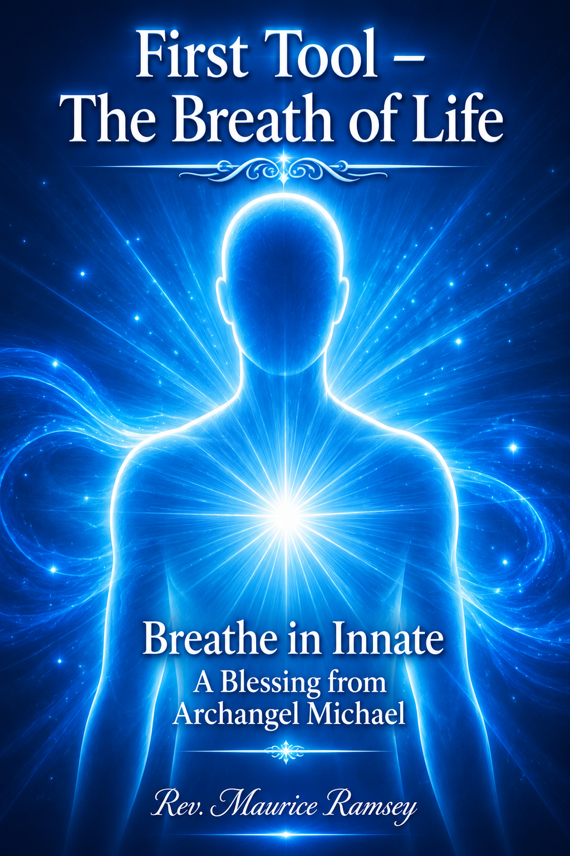

First Tool – The Breath of Life
We begin with the First Tool — the Breath of Life, the beautiful energy and essence that connects you instantly to the Seventh-Dimensional frequency.
I ask you now to take a deep, inhaling breath and allow your body to expand and to breathe — breathing in the Breath of Life and holding within you the essence and power of this beautiful Life Force Energy, which is the breath of God.
As you hold this frequency — the Vital Life Force of the God Essence within your breath — we ask you to relax, surrender, let go, and let God. Relax. Surrender. Let go, and let God.
It is unfortunate that many, including yourself, have forgotten how to truly connect with their own breath. Yet as you begin to breathe consciously, you allow yourself to connect to your Innate Wisdom and to your Higher Self.
When you fully breathe, you align yourself with your Higher Self and the power of the God Essence within you.
So breathe, Dear One. Breathe.
Breathe in the Life Force of your own energy.
Breathe in the Life Force of God.
Simply begin to breathe

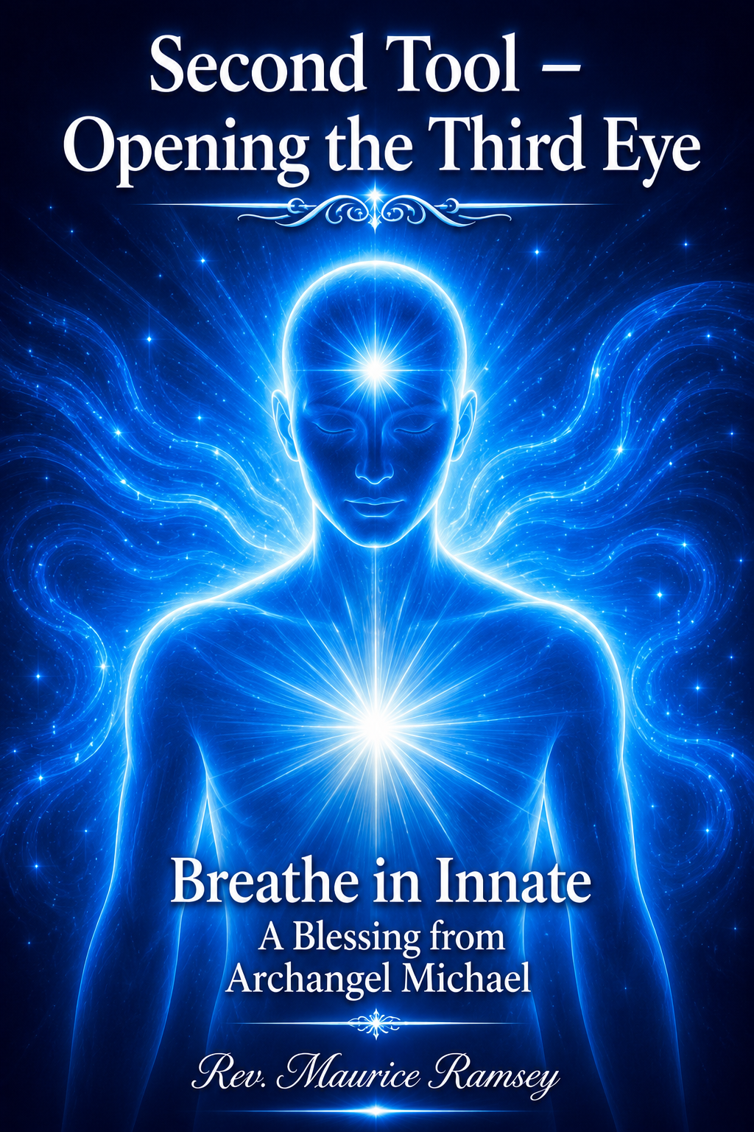

Second Tool – Opening the Third Eye
The Second Tool is the opening of your Third Eye, allowing yourself to move into a state of expanded awareness.
Focus your attention upon your Third Eye. God has gifted you with this beautiful energy of sight — of clairvoyance.
It is here, between your brows, that your Third Eye resides. It is connected to your Pineal Gland, where all the ancient wisdom teachings are held — where your Innate Wisdom abides.
So breathe into your Pineal Gland.
Breathe into your Third Eye.
This is how you connect to your Innate Wisdom.
Through your breath, all that you have ever been, and all that you shall ever become, is awakened within the Pineal Gland.
So, breathe, Dear One.
Breathe in the white energy of God into your Third Eye.
Breathe into your Pineal Gland and allow your heart to open and your mind to expand.
Breathe in the energy and awareness of All That Is.
So breathe, Dear One…
Breathe deeply into your Third Eye.

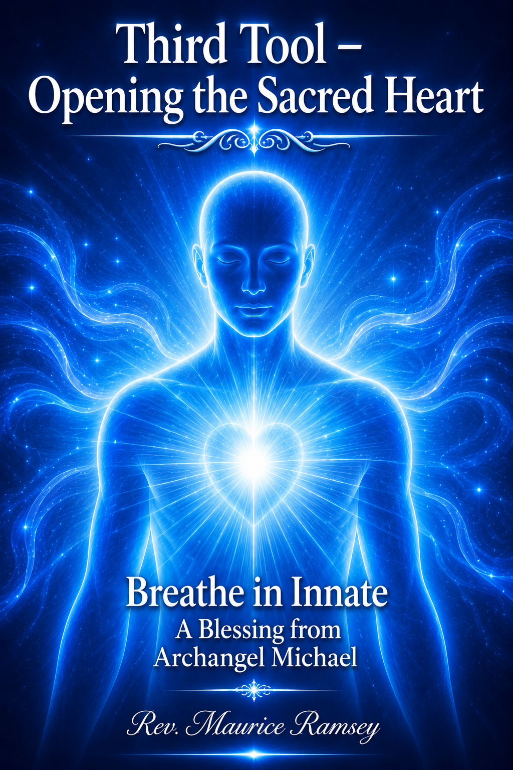

Third Tool – Opening the Sacred Heart
As we move into the Third Tool, focus on opening your Heart Chakra, and there, within your Sacred Heart, hold love for yourself.
Allow your beautiful Sacred Heart to open like a lotus flower in full bloom. Your Sacred Heart holds the purity and innocence of your Soul, and it is within this purity and innocence that you are able to tap into your Innate Wisdom.
So, breathe, Dear One. Breathe, and allow your heart to open and awaken like a beautiful lotus flower. See your Sacred Heart opening.
Know that you are a pure vessel of Love and Light.
Breathe into your Sacred Heart with intention.
As you open the energy of the Sacred Heart, I ask you to awaken your High Heart — the bridge between your physical and spiritual self.
Awaken your physical heart, and awaken your High Heart.
Your High Heart is located in the center of your upper back, behind your physical heart. So breathe into your High Heart. Breathe, Dear One. Breathe into your heart with divine intention.
Your Heart Chakra is the gateway to your Sacred Heart — the sanctuary where you hold love for yourself. Allow this Sacred Heart to open gently, like a radiant lotus flower unfolding in purity and light. Within this Sacred space lives the innocence of your Soul, and it is through this purity that you tap into your Innate Wisdom.
So, breathe, Dear One, breathe… and allow your Sacred Heart to awaken and blossom. See it opening with grace; know that you are a pure vessel of Love and Light. Breathe into your Sacred Heart with intention, and as this Divine energy expands, awaken your High Heart as well. Your High Heart rests at the center of your upper back, behind your physical heart — the bridge between Heaven and Earth within you. So breathe into your High Heart… breathe, Dear One, and let your breath awaken both hearts in perfect Divine harmony.
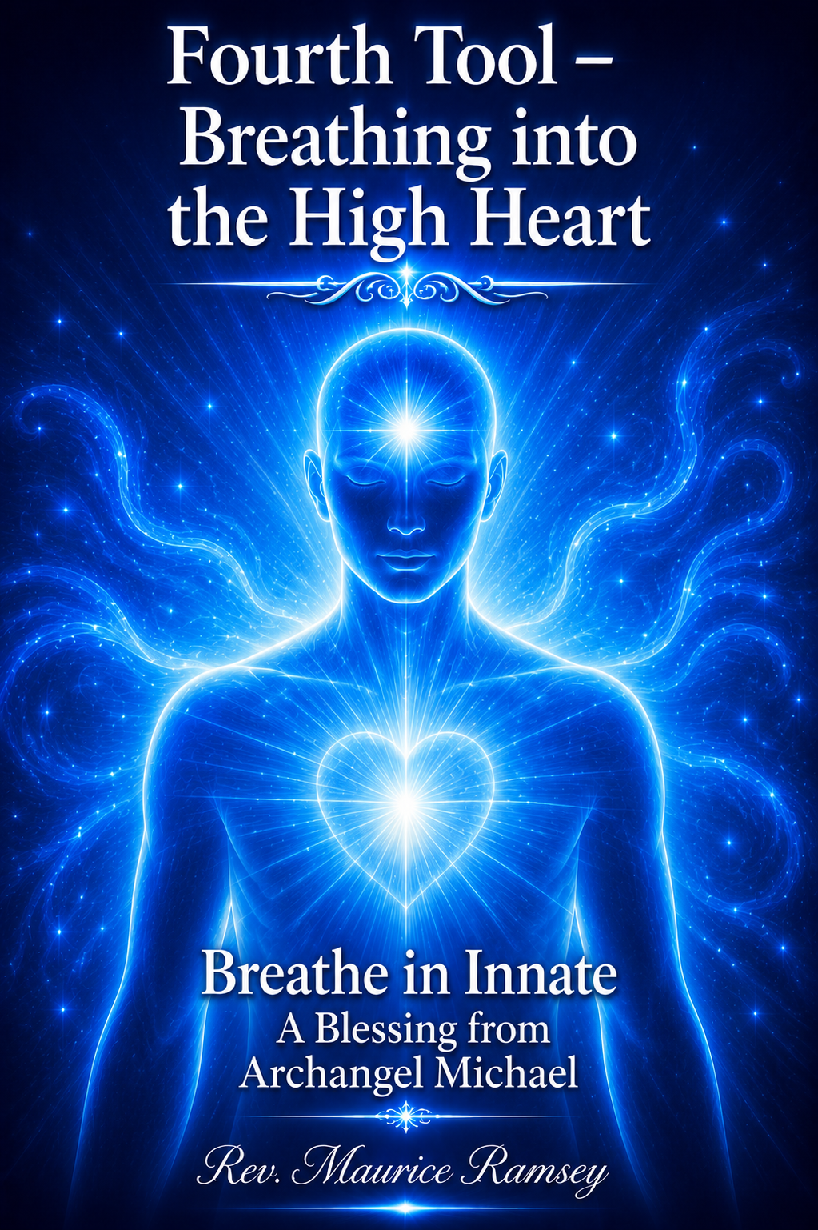

Fourth Tool – Breathing into the High Heart
As we move into the Fourth Tool, we ask you to begin once again to breathe into the energy of your High Heart.
It is through your High Heart that you connect to Divine Love.
As you breathe, allow yourself to feel the energy of pure love and pure understanding — the awareness that we are all One, and that you are eternally connected to your Innate Wisdom.
As you expand into the dimensions of all that you have ever been and all that you shall ever become, allow yourself to expand even deeper into your High Heart and simply breathe.
Breathe with the intention of opening your heart to Oneness — opening your beautiful heart to feel love on all levels, for yourself and for all aspects of your being.
So breathe into your High Heart, Dear One.
Breathe…
Breathe…
and breathe.

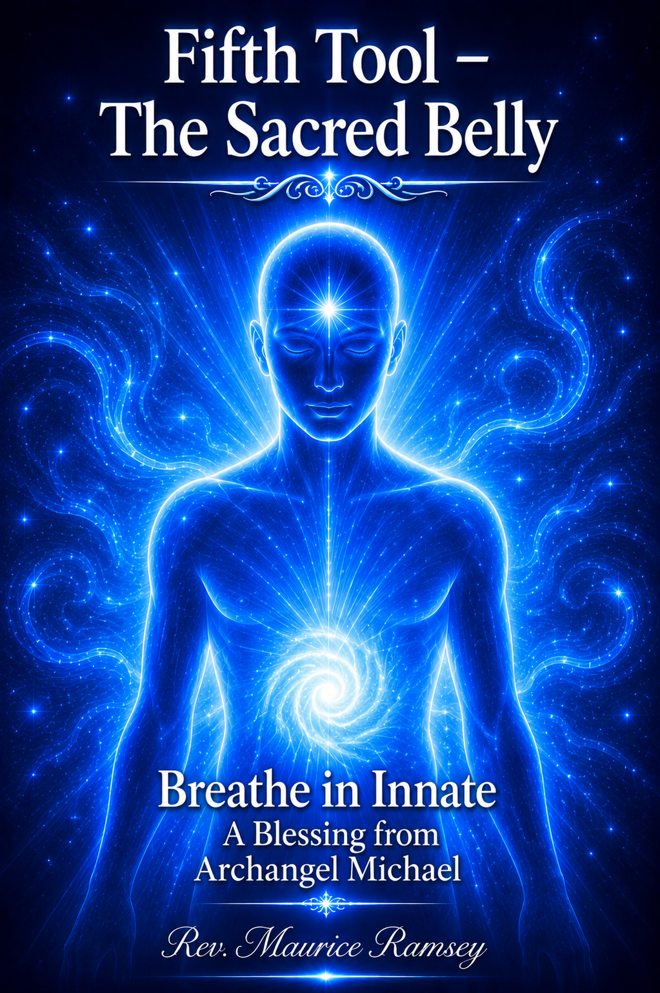

Fifth Tool – The Sacred Belly
As we move into the Fifth Tool — your Sacred Belly — we ask you to allow this beautiful center of creation to open.
Begin to breathe the energy of Love into your Sacred Belly, expanding the pure White Light frequency within it. Breathe, Dear One, breathe into your Solar Plexus, allowing the energy of this beautiful essence to flow through you.
It is through your breath that you form the energy of Creation itself.
Buddha — the Laughing Buddha — held the energy of laughter within his Sacred Belly. He knew and understood the power of the Sacred Belly. He understood the power of Love and the power of Laughter.
It is here, in the secret of the creative Life Force Energy of your breath, that you are able to tap into your Innate Wisdom.
Breathe into your Sacred Belly and laugh! Feel the joy! Breathe, laugh, and feel the joy rising within you. Breathe into this Sacred center that awakens your Kundalini, and allow this energy to enliven every cell, every pore, every essence of your being.
Allow yourself to feel the energy of the Sacred Belly beginning to open — awakening the radiant energy of all your cells and the luminous essence of your Merkabah Light Body.
Breathe, Dear One, breathe.
Laugh, breathe, and hold your Sacred Belly with joy and laughter — in freedom and peace.
So, breathe, my children, breathe.
Allow yourself to feel the creative Life Force Energy flowing through you, connecting you to the Oneness of All That Is, and awakening the laughter and joy within your Sacred Belly.

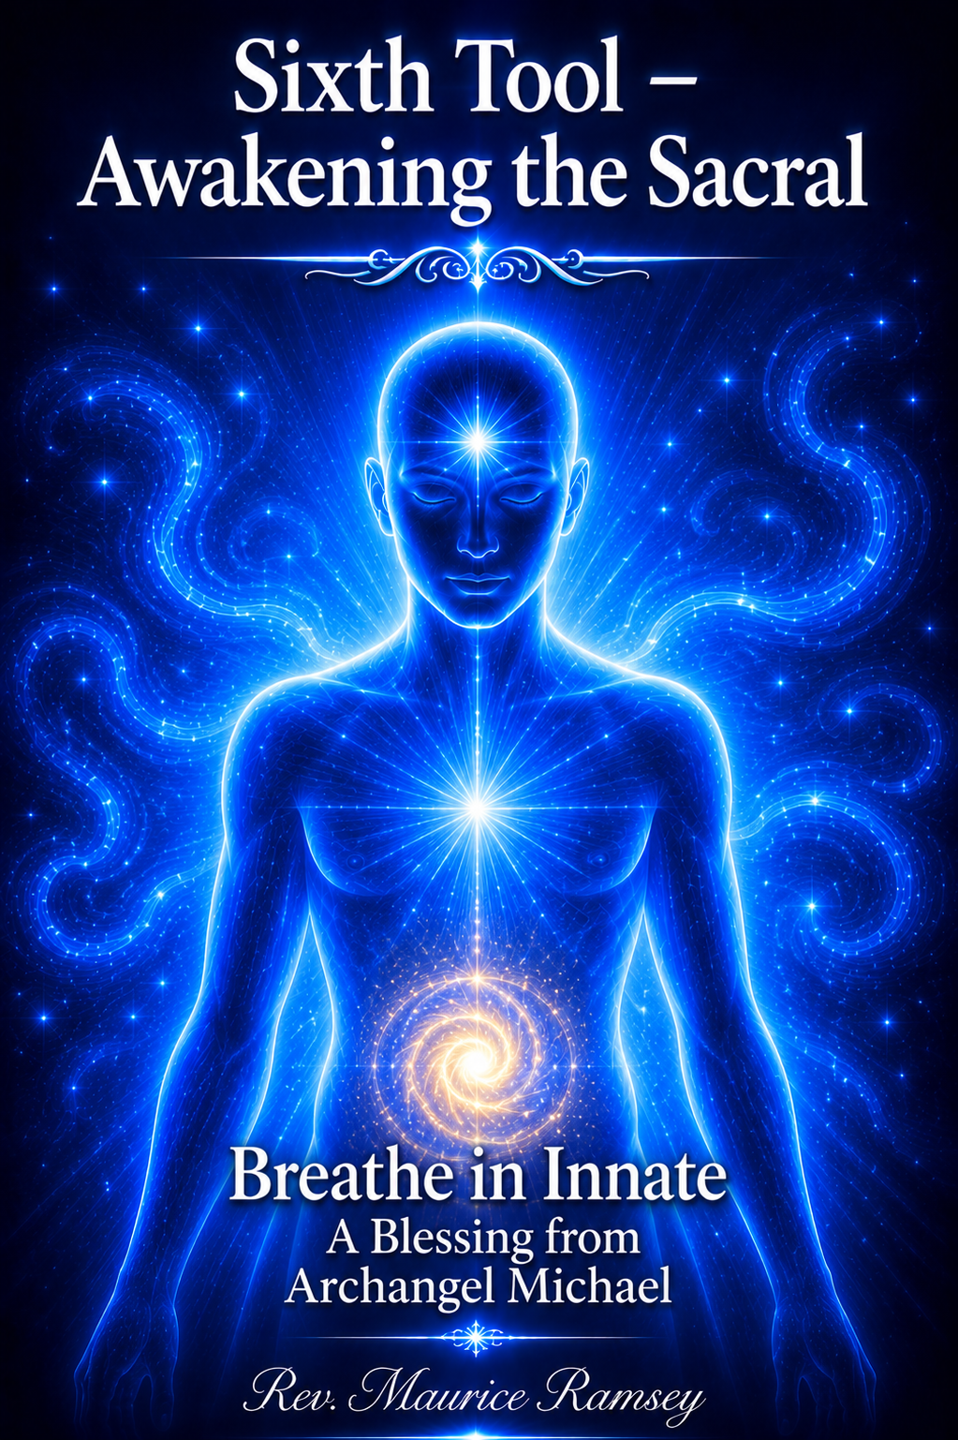

Sixth Tool – Awakening the Sacral
As we move into the Sixth Tool — the energy within your Sacral — feel the rising of the Kundalini from your Sacral and Coccyx, the base center of your spine. This is your Sacred holding point, the foundation that connects you physically to Mother Earth.
Feel the essence of your beautiful Sacral energy — the radiant energy of Mother Earth herself — and breathe this Sacred vibration through your Sacral.
Breathe and release…
Breathe and release…
Breathe and release into your Sacral.
Your Sacral has been held still for too long.
Now, allow the Vital Life Force Energy of Mother Earth to move freely through you. This is how you connect to your Innate Wisdom — by grounding through your Sacral and merging with the living energy of Mother Earth.
And so, dearest child — dearest Maurice — open your Sacral.
You are no longer stuck. You are free.
It is here that you allow your Kundalini to rise, as the Prana Life Force Energy moves through you.
Breathe with intention.
Breathe with intention.
Breathe with intention.
Breathe with the intention that you are free.
Breathe and release, and open your Sacred Heart to set yourself free.

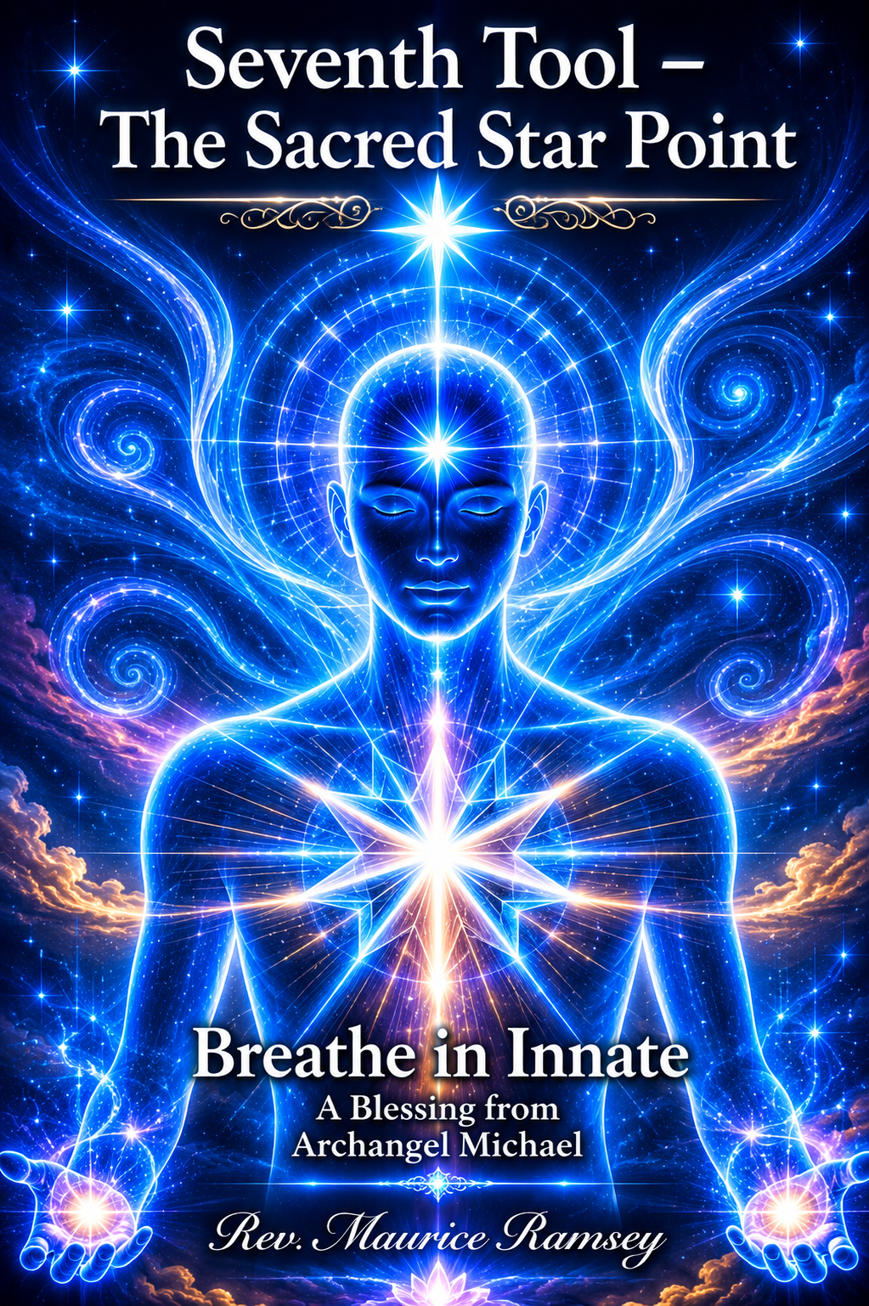

Seventh Tool – The Sacred Star Point
As we now move into the Seventh Sacred Tool — the Sacred Star Point — allow yourself to feel this beautiful energy of the Diamond Heart and the Diamond Light.
Allow your own radiant Diamond Light to begin to open, flowing into your Sacred Star Point. These Star Points are powerful energy centers located behind your physical knees; they hold and ground you to the Earth.
Your beautiful Diamond Light Frequency is awakening now.
This is how you connect to your Innate Wisdom — by opening this Sacred energy and drawing in the Star Point through your breath, as a gateway between your physical body and Mother Earth.
As you move this energy from Mother Earth into your Star Point — into the Diamond Frequency within you — it allows you to move forward in your divine life mission.
So, begin to breathe and move forward into your mission.
Breathe into the Sacred Star Point.
Breathe the life essence of Mother Earth into your body.
Breathe, Dear One, breathe.
By holding this powerful vortex of energy behind your physical knees, you are now able to connect deeply with the Earth, to align with Father Sky, and to merge with your own Innate Wisdom.
This Sacred energy grounds you into the third dimension while allowing your Light to remain free and expansive.
So breathe with intention — into your High Heart, into your Sacred Star Point — and simply breathe.

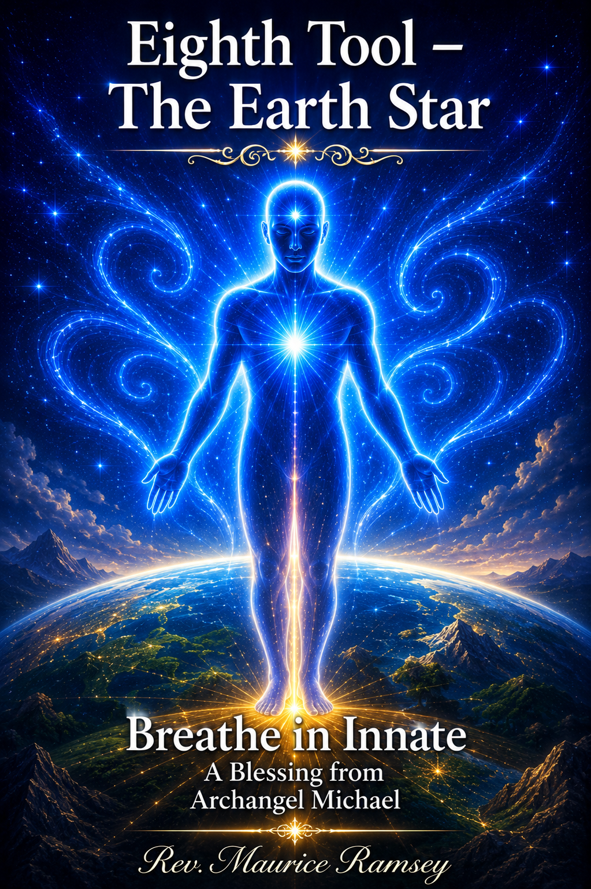

Eighth Tool – The Earth Star
As we move into the Eighth Tool — the Earth Star — feel the powerful energy within the very soles of your physical feet.
This Sacred energy connects you deeply to Mother Earth herself.
So breathe, dearest child, breathe.
Breathe, dear Maurice, breathe.
Breathe in the energy of the Earth Star and open it within the soles of your feet, connecting your breath to the Earth.
Breathe with intention and open this beautiful portal.
It is time to allow yourself to remain connected to Mother Earth — in your physical body, in your mind, and in your emotions — in all aspects of your being.
During this great paradigm shift within you, it is essential that you stay grounded to the Earth and fully present within your body.
And so, breathe, Dear One, breathe — this is the power of the Earth Star.
The new energy of the planet is extremely powerful.
Because of this paradigm shift, you are now able to hold the energy of Mother Gaia within your being — in your physicality, in your breath, and in your Light.
This connection allows you to access your Innate Wisdom.
So breathe into the Earth Star.
Understand that beautiful Mother Earth is now opening and expanding — a radiant star of Love and Peace.
Breathe in her essence and feel her energy rise through the soles of your feet.
Breathe in the beautiful Earth Star so that you, too may begin to ascend as a Sacred Being of Light, as Mother Earth herself ascends.

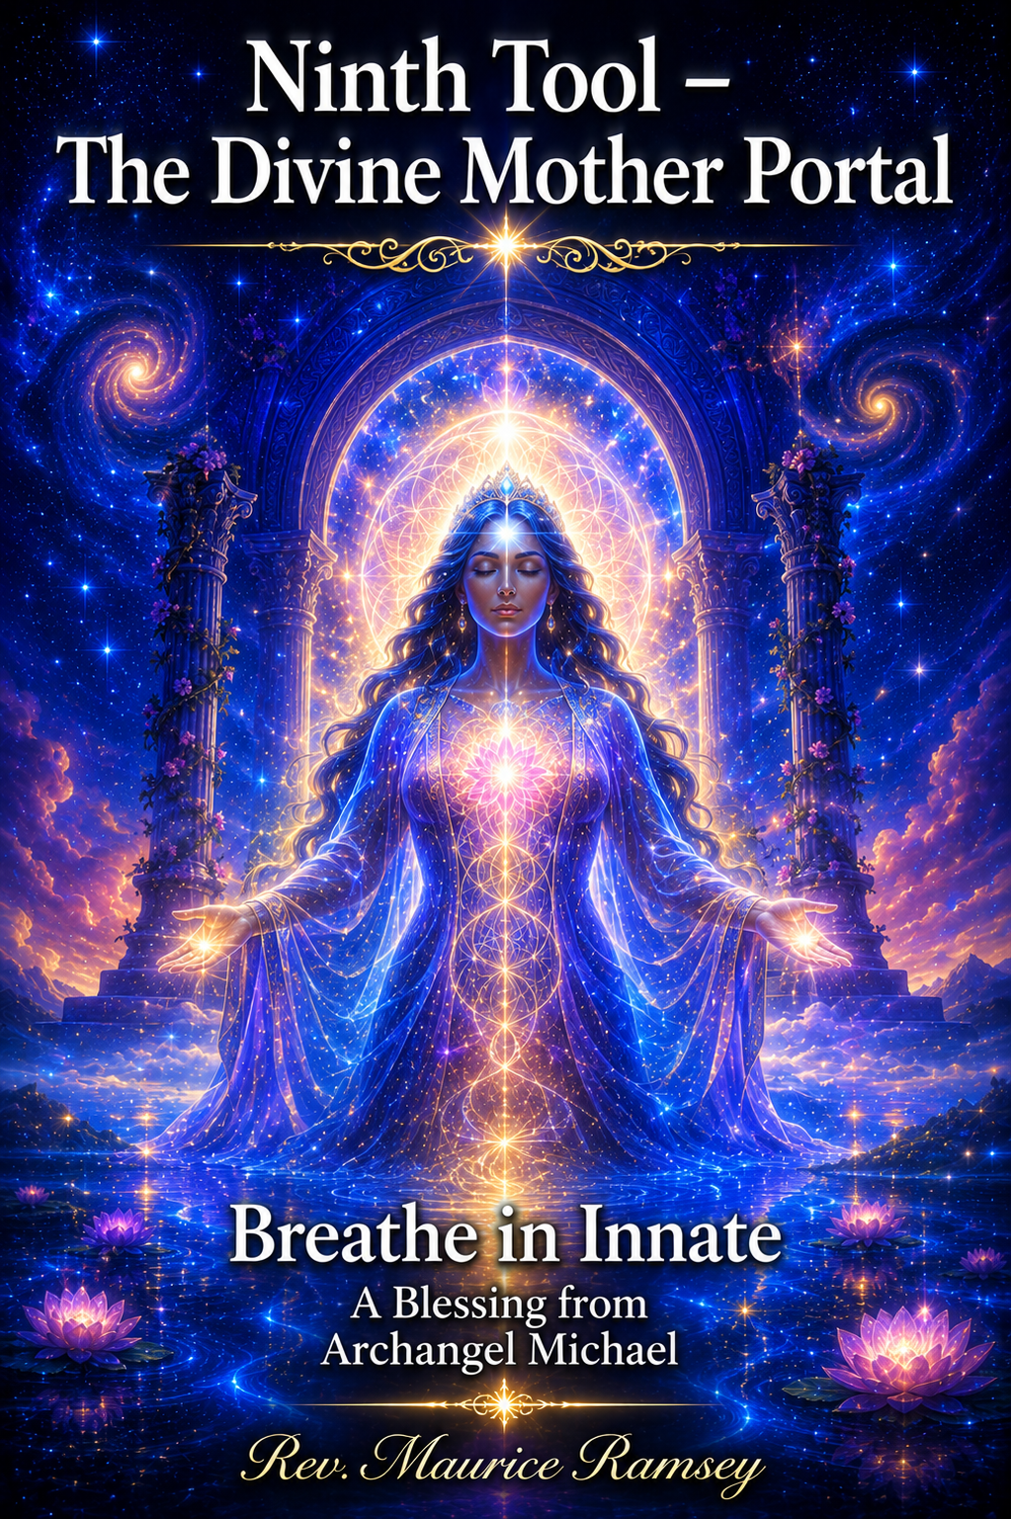

Ninth Tool – The Divine Mother Portal
As we move into the Ninth Tool — the Divine Mother Portal — breathe with intention and enter the crystalline grid of Mother Earth, the radiant energy of the Divine Feminine. This is not the crystalline core of the Earth but a gateway — a portal of love and light connecting you to Mother Gaia’s Sacred essence.
As you enter this gateway, feel unconditional love, peace, joy, and compassion embracing you. So breathe, my children, breathe.
Breathe, dear Maurice, breathe.
Feel your connection to the Divine Mother, for this is a powerful gateway — a living portal to the Divine Feminine and to Mother Gaia herself. When you first chose to come here, you entered through this portal, welcomed by her love.
She received you as the beautiful Star Seed that you are. She acknowledged your spirit and welcomed you home into your physical body upon the Earth.
Now breathe in her loving energy — the essence of the Divine Feminine — and honor the knowing that she lives within your very being. Breathe this Sacred connection with deep intention.

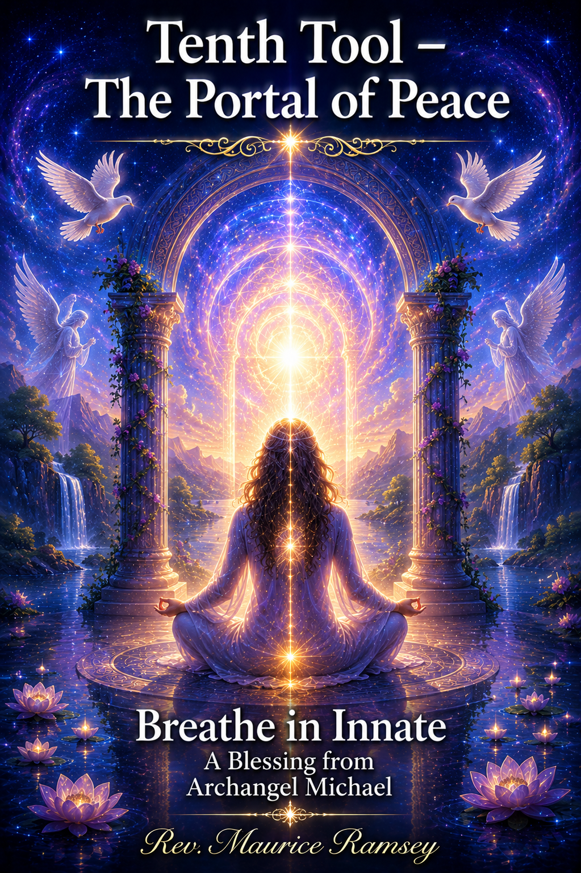

Tenth Tool – The Portal of Peace
As we move into the Tenth Tool — the Portal of Peace — breathe deeply and feel this Sacred connection. You are a powerful being of Light who chose to be here during this new age of enlightenment, to assist the planet in her great transformation.
Breathe and move into the energy of Divine Love and Peace, and allow yourself to enter the Sacred current of Mother Gaia’s Portal of Peace. This portal is held in the sixth-dimensional frequency, opening through your Earth Star Point as you breathe with intention.
Long before your birth, you rested within this Portal of Peace, embraced by calm and divine harmony before entering the Earth plane. There, your being was infused with the vibration of peace, preparing you to embody it upon the planet.
I, Joshua , come now to help you awaken this powerful portal within. You are a physical being of Peace, Love, and Light. Breathe with purpose and reconnect to the Divine Feminine through Mother Gaia’s Peace Portal.
You entered this Earth as a joyful, peaceful spirit. So breathe in that remembrance, and hold the vision of Earth restored to her original design — a planet of peace and love. You are here by divine design to breathe, to remember, and to assist Mother Earth in returning to Oneness through your own Innate Wisdom.

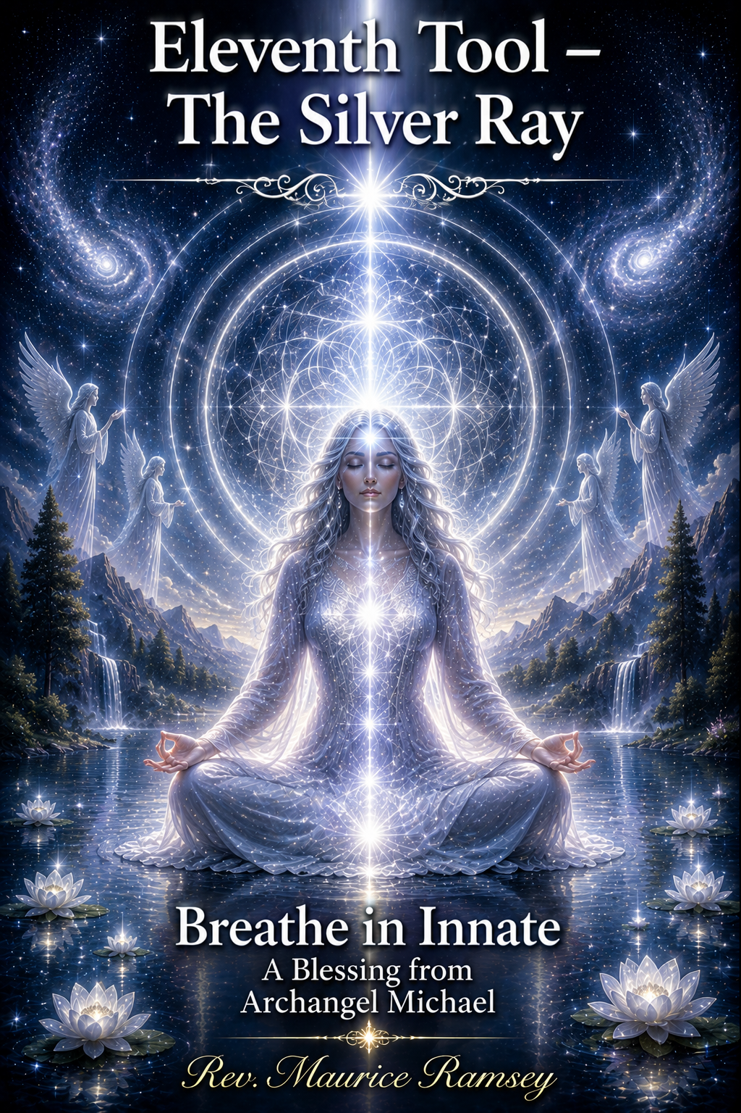

Eleventh Tool – The Silver Ray
We now move into the Eleventh Tool — the Silver Ray — a renewed paradigm of Light for this age of enlightenment. It connects you to the beautiful essence of the Silver Star, the radiant energy that links you to your Higher Self and the Divine.
Each soul carries a Silver Cord, connecting your spirit to your Higher Self while keeping you grounded to the Earth. When the time comes to leave the physical body, this Silver Cord gently releases, allowing your spirit to return to its true essence — your Innate Wisdom and Eternal Light.
The Silver Ray merges you with all that you are across every multidimensional level of space and time. So breathe, Dear One, and draw in the Silver Light with deep intention.
This is your Life Force Energy — the essence of All That Is, the Light of the Great Creator flowing through you. Breathe in the Silver Ray and feel it anchor you to Mother Earth, for it is your living lifeline of peace, love, and divine remembrance.

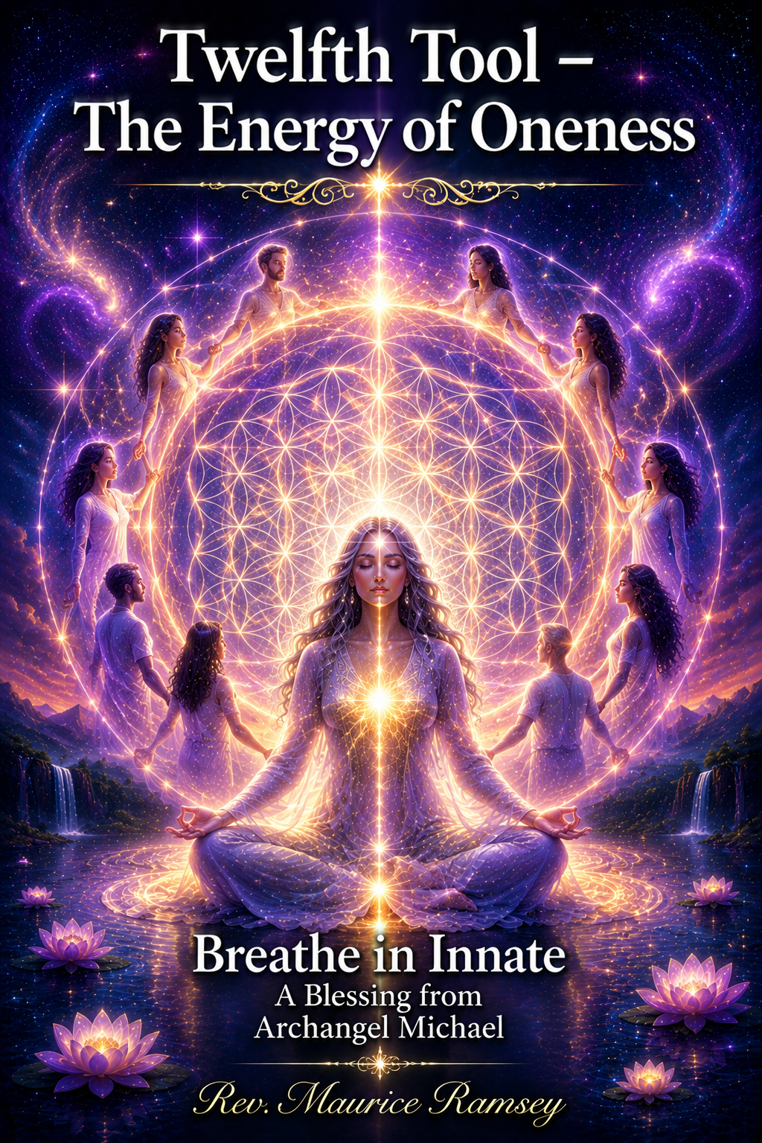

Twelfth Tool – The Energy of Oneness
And finally, we move into the Twelfth Tool — the Energy of Oneness. Breathe with intention the Sacred Energy of Oneness as you expand your essence into the beautiful White Light Frequency of God. Feel the power of this Divine Light surrounding you, embracing you, protecting you, and encompassing your being — for you are the White Light.
Remember, Dear One, there is no time, no space, and no separation. There is only Oneness. Through this Oneness, you are connected to your Innate Wisdom. You are Light. You are Love. You are Freedom and Joy. You are not merely an individual in a physical body — you are a Spirit of Light connected through the energy and essence of All That Is.
Breathe in the essence of this beautiful White Light and allow yourself to feel peace flowing through every fiber, every cell, and every pore of your being. Breathe. Breathe in the White Light of God. Breathe in your Oneness. Breathe in the Silver Ray — the Silver Star which crowns you within the energy of Mother Gaia.
As you move through the Peace Portal of the White Light of God, allow yourself to enter the Divine Gateway of Mother Earth — the Sacred portal of Unconditional Love, Peace, Joy, Oneness, Harmony, and Balance.
Breathe this energy into your Soul and into your physical form.
Move through each Sacred center with intention:
- Into your Earth Star, grounding your Light.
- Into your Sacred Star Point, anchoring your divine connection.
- Into your Sacral, awakening freedom and joy.
- Into your Sacred Belly, filling with laughter and creative Life Force.
- Into your High Heart, radiating love and gratitude.
- Into your Sacred and Merciful Heart, expressing compassion and mercy.
- Into your Third Eye, expanding clarity and knowingness.
- And finally, into your Pineal Gland, holding the ancient wisdom that connects you to All That Is — the very source of your Innate Wisdom.
May your heart awaken to the essence and presence of this Sacred energy. May you feel the Light of God around you as you choose to be the Light of the World. Remember always — you are the Living Breath of God made manifest.

Closing Blessing
And so, Beloved One, remember always:
The Breath of God lives within you.
With every Sacred breath, you awaken the Light of your own Divine Presence.
With every breath, you reconnect to your Innate Wisdom.
With every breath, you return to Peace, Love, and Oneness.
May the Twelve Sacred Tools continue to open within your being like living flowers of Light.
May your heart remain open.
May your breath remain conscious.
May your spirit remain free.
Walk gently upon the Earth.
Breathe with intention.
Love with an open heart.
And remember always:
You are not separate from God.
You are the Living Breath of God made manifest.
And so, it is.
With Love, Peace, and Divine Blessings,
Rev. Maurice Ramsey

