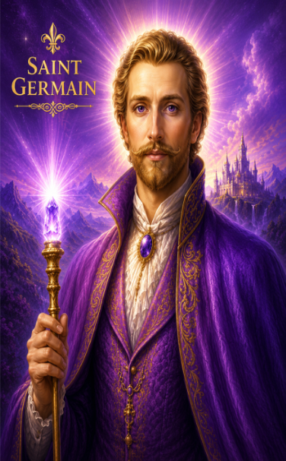
Saint Germain's Transmission
Channel by Lea Chaplin – June 30, 2026

Hi, Maurice, thank you for your question. I will invoke the energy of Master Saint Germain. Father, Mother, God, we call forth the highest frequency, the highest light for Maurice's soul growth.

As always, Father, surround us with your love, light, healing, wisdom, and truth, as we once again invoke Master Saint Germain to step forward to bring his words of wisdom, healing, and guidance for this beloved soul. And as always, Father, surround us with your holy protection, and this we give our grace, and so it is. Greetings, Dear Son.

Yes, it is I, Saint Germain. I bow to you, Dear Son, for your love and devotion unto the great commitment of serving the living God. It is through the power of the Violet Fire, the Violet Flame, the sacred frequency of the Violet Flame of Transmutation that will begin to heal you on all levels, mentally, emotionally, physically, and spiritually.

Violet Flame of Healing
“As I invoke the energy of the Violet Flame to heal me, I call forth, in the name of the “I AM” of my being, I call forth the action of the Violet Flame of Transmutation, Compassion, and Forgiveness in my auric field, for the cleansing and purifying of every thought and feeling in my solar plexus and all my chakras.

I ask the action of the Violet Fire to permeate every cell, atom, and electron of my four bodies, at this moment, at all times, each day of my life, 24 hours a day, seven days a week, for the healing of all distortions in my energy field from past and present misunderstandings. I ask the energies of the Violet Fire to start healing all distortions in my physical, emotional, and mental body.
With much gratitude, I now ask for the action of the Violet Fire to manifest in my energy fields now, in full power. So be it, Almighty I AM.”

As you visualize this, and as you invoke this invocation, the more you will stay in your heart, the more momentum it will build. As you call in the energy of the Violet Flame daily, you shall begin to receive the healing that is so needed, for you begin to clear, as has been said, all the distortions that have been held within your own soul and your own soul's essence.

And so, in this moment, you have been called to me, Saint Germain, to begin to work with clearing these distortions that no longer serve you: lack, limitation, fear, resistance, shame, blame, guilt. As you begin to honor yourself, may you call in and invoke the Violet Flame again.

As you invoke the energy of the Violet Flame, may you feel this energy begin to build within you. Begin to build and open yourself to a greater level of compassion for your own healing, and for the healing of those you love. Whatever it is that you feel needs healing in your life, invoke the energies of compassion and forgiveness into it, and allow the changes you want to take place to occur.

“I invoke the Violet Flame into my life. I open myself to a greater level of compassion for my own healing, and for the healing of those I love. Once again, I invoke the energies of compassion and forgiveness into my being, and allow the changes I want to take place within me. And once again I invoke the Violet Flame.”

“As I invoke the energy of the Violet Flame to heal me, I call forth, in the name of the “I AM” of my being, I call forth the action of the Violet Flame of Transmutation, Compassion, and Forgiveness in my auric field, for the cleansing and purifying of every thought and feeling in my solar plexus and all my chakras.

I ask the action of the Violet Fire to permeate every cell, atom, and electron of my four bodies, at this moment, at all times, each day of my life, 24 hours a day, seven days a week, for the healing of all distortions in my energy field from past and present misunderstandings. I ask the energies of the Violet Fire to start healing all distortions in my physical, emotional, and mental body.
With much gratitude, I now ask for the action of the Violet Fire to manifest in my energy fields now in full power. So be it, Almighty I AM.”

Stay in the state of bliss and gratitude. As you feel the shift begin to shift within you, consciously request the Violet Flame to begin to heal you on all levels. Do not become uneasy or fearful.

“I consciously request the Violet Flame to begin healing me on all levels of my being. May this healing occur in perfect alignment with the highest good, and I seal this prayer with the words: "Thy will be done.”

Take the time. Do not feel rushed with what you need to heal. I invite you to step into my frequency, for my energy, my essence, is always available to you.

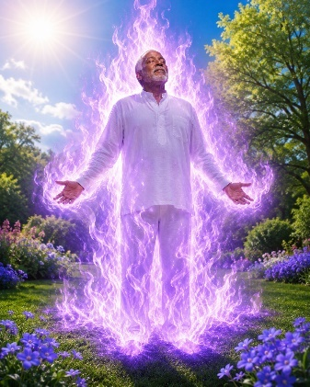
In the Name of God, "I AM that I AM,” "I AM that I AM,” “I AM that I AM." In the Name of my Mighty “I AM Presence,” I call upon the Violet Flame and the Power of Saint Germain together with the Higher Vibrational Frequency of the White Light of God. I invoke Saint Germain's presence into my auric field, allowing my Higher Self to merge with the Essence of Saint Germain. And so, it is.

I stand in St. Germain Essence

And so now in this moment, as you invoke the beautiful flame, feel the energy of love. Step forward upon your own soul. Feel the energy of love begin to heal you.

Feel yourself become lighter and lighter, and feel the lightness of joy and freedom. As you allow yourself to feel greater joy, you lessen your burdens. Allow this lightness, this love, to nurture you.

“I keep breathing in and calling forth the Violet Flame of transmutation to heal me. I continue to breathe in the frequency of the Violet Flame as I allow the energy, as said, to begin to heal me. And so, as I invoke the frequency of the Violet Flame, I begin to be heal and release, let go and let God.

And so, as I call forth this frequency, in the name of the Great “I AM that I AM,” I call forth the action of the Violet Transmuting Flame to be activated within my entire consciousness and being. Violet Fire from the heart of God, expand thy light through me each day. Transmute and heal all my human imperfections into the shining diamond of God's heart in Christ's perfection.

As I surrender to their radiant light, take dominion over my life. Blaze into action the mercy's flame of the compassionate heart. Expand and saturate within me the wonders of the Violet Light until I am totally transformed.”

Beloved “I AM Presence,” send the Violet Flame to purify every cell, atom, and electron in my being until I'm raised into my eternal victory by the action of the Violet Fire and the Ascension Flame. And so, it is. Beloved “I AM.”

And so, as you call in this beautiful frequency, may you allow the energy to transmute, again, all that no longer serves you. And allow yourself to feel this frequency as the energy of the Violet Flame begins to bring healing to you at all levels. You will begin to call in the Violet Flame to begin to heal your circumstances, to begin to clear the discordant energy around yourself, your family, your home, and your environment.

And begin to call in the higher frequencies of love, of the Cosmic Flame of Love, that will allow you now to shift your life into a greater sense of love, prosperity, and abundance. Calling in the energy, once again, of the beautiful frequency of the Cosmic Flame of Love. Breathing in the energy, bringing the essence of the Cosmic Flame of Love into your being.

I breathe within me the Cosmic Flame of Love. I breathe within me the Cosmic Flame of Love. And so, allow my heart to sing, my mind to be healed.

And as I begin to shift my consciousness from fear to love, as I allow the beautiful energy of the Violet Flame to transmute all fears, all worries, all sadness, and all sorrow, I begin to feel the sense of freedom within me.

And truly may the love of God surround me, the power of God protect me, the presence of God watch over me, wherever I am, God is, and all is well. May I feel the power, may I feel the “Presence,” may I feel the energy of God's Living Light upon my soul.

“As I invoke the energy of the Cosmic Flame of Love and the Violet Flame of Transmutation, I begin to feel this frequency, and allow the energy of Divine Love to be the focus that guides my life. Allowing the energy of Divine Love begins to flow through every cell of my being. As I become a living stream of pure Divine Love, the Violet Flame will transmute anger, hatred, greed, negative thoughts and feelings, all discordant energy.”

The Power of the Cosmic Flame of Love, together with the Violet Consuming Flame, transmutes all that is unlike God, allowing me to embody the fullness of Divine Love within my Mighty "I AM Presence."

The Power of the Cosmic Flame of Love will transmute along with the Violet Flame so that I can begin to embody the power of Divine Love within my “I AM Presence.” As I proclaim, “I AM that I AM,” “I AM that I AM,” “I AM Love,” I live in the consciousness of love.

“I AM Love” in its fullest expression. Blessing myself and all mankind with Divine Love, I radiate love.

“I AM” love in action, blessing and uplifting and healing myself, my family and all those I love and planet earth herself. And so, as I begin to feel this energy rise within me, know that the power that I am holding within my “I AM Presence” is a true divinity that I, Saint Germain, am bringing forth at this time.

I'm holding you in the palm of my hands, Dear Maurice, and I'm transmuting, clearing, releasing, and you will do this for others. It's why you have to go through this first yourself so you can be of assistance to help others. As you invoke the energy of the Violet Flame and invoke the energy of the Cosmic Flame of Love, you'll begin to heal others at a very deep level.

Beloved Mighty “I AM Presence,” I invoke the Violet Flame, and I invoke the energy of the Cosmic Flame of Love, as I begin to heal myself and others around me at a very deep level, “Almighty I AM.”

Feel their power, feel their love, feel their beauty, feel their strength as you know and you feel the essence of Divine Love within your own soul. “Beloved I AM,” “Beloved I AM,” “Beloved I AM.”

May you feel the love of God truly surround you, may you truly feel the power of God; may you truly feel the innocence of God, the love of God, the joy of God. As this beautiful frequency of the Violet Flame begins to heal and to bring forth healing to you, to all souls, and to this Beloved planet.

And simply know in this moment of this time the power that you hold, the love that you hold, the peace that you hold is indeed love. And so, honor yourself, honor the light that you carry, honor the joy that you carry, honor the peace that you carry because you, as I've said, with the help of myself, Saint Germain, will begin to help transmute and to heal those that need healing. So, there can be peace on earth, peace on earth, peace on earth.

And so, as you call forth this frequency, may you trust in the remembrance that all is in order and all is as it should be. As you feel the power of love in the sacred light of All-that-Is. Go now, my son, be at peace and be still and know that you are loved.

For you are bringing forth tremendous healing to yourself, tremendous healing to your family, tremendous healing to all souls, and to Mother Gaia herself.

And so, know that you're making a difference in the world and that by calling on us, the masters, we hear your call and we are here to assist you in this uplifting of the energy of love upon our planet. Go forward in peace.

Go forward in peace. Go forward in peace and truly know that you are loved. Love beyond comprehension, loved beyond measure.

Truly know that you are loved. Go forward in peace, go forward in peace, go forward in peace. And we thank you, Saint Germain.

And this we are grateful for: this healing and this restoration and the transformation for Dear Maurice, for his family and all those he loves and for Mother Gaia herself. We honor you, we bless you, and we are truly grateful. And so, it is.

https://www.mauriceramseyhealingcenter.com/general-4

With love and blessings,
Maurice Ramsey
Minister of the Light

