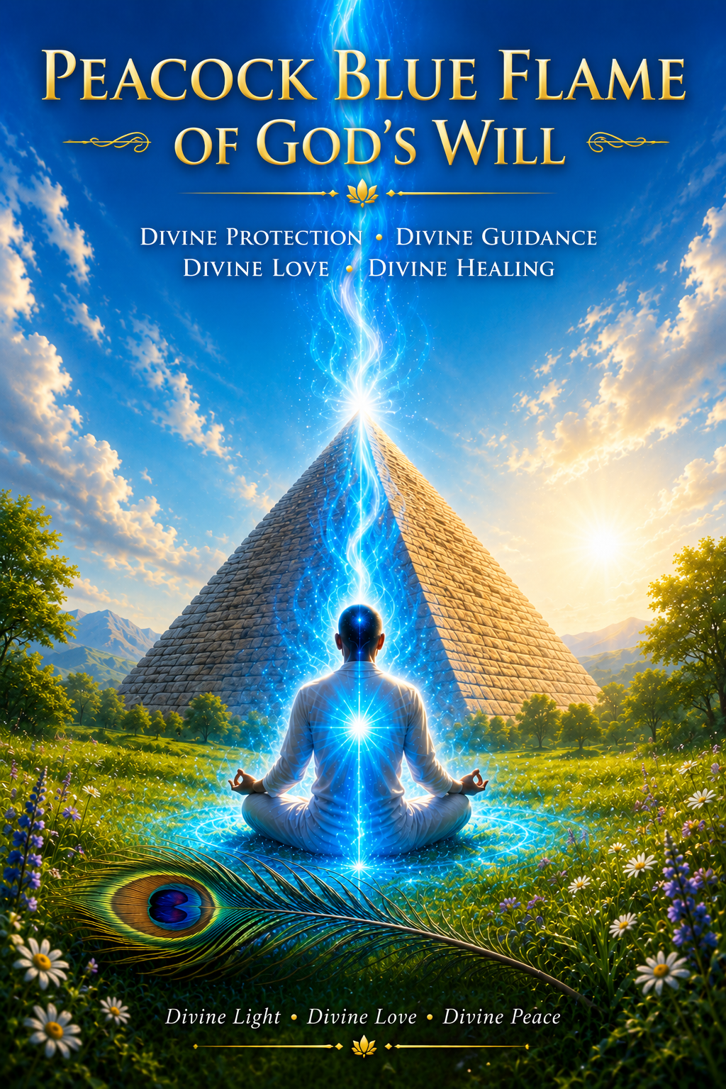
Peacock Blue Flame of God’s Will

Father, Mother, God, we call forth the highest frequency. The highest light for Maurice is soul growth. As always, Father surrounds us with your love, light, healing, wisdom, and truth. We call forth the energy of Archangel Michael to step forward, to bring his words of wisdom, healing, and guidance for this beloved soul. We also call on the energy of Master Jesus to step forward and bring his words of wisdom, healing, and guidance for this beloved soul. We ask Dear Sarah to step forward to bring her words of healing, guidance, and wisdom to this beloved soul. And so, it is.
Greetings, Dear One. Yes, it is I, Christ; I am here. Dear One, to help you to understand that the energy of the Great Pyramid and what you call the Peacock Blue Flame is a powerful frequency of energy that is transmuting your own energetic soul matrix. What you are envisioning is truly the Etheric Pyramid that is being brought forth with the Blue Flame of Archangel Michael to restructure your soul matrix and to realign yourself with your true Divine, authentic self. And so, as you begin to breathe in this beautiful Peacock Blue Flame of Light and imagine the Etheric Pyramid of energy over your head, you are being reintegrated and downloaded with this powerful frequency of the Blue Flame,

Allowing the energy of Archangel Michael's strength, wisdom, power, and great devotion to be brought into your physicality so that you can remain healthy and strong, bringing the strength within your mind so that you can be healthy and strong, and breathing in the energy of the Blue Flame into your heart so you may be healthy and strong. And so, call in this frequency as you call in this powerful love and light and peace as you truly begin to surrender to the Blue Flame of God's Will of Father, Mother, God into your hands I command my being; use my love, my thoughts, and my life and selfless service to release me from all the hindrances

Master Jesus, release me from all that hinders me, and that keeps me from my true purpose and ascension. Teach me to be kind in the way the Brotherhood of Light directs, and establish my live stream in the way set daily and hourly by true identity and God manifest, beloved God, God presence. “I AM” Eternal Father, Mother, God. May the covenant I made with thee be totally fulfilled; may I live my life to feel your love and see your light. May your will manifest on earth as it is in heaven into my hands. I surrender my being through me; allow all things to now be in divine order. And so, it is beloved “I AM.”
And so, as I call in the Peacock Blue Flame of God's Will, allowing the power of surrender to truly be within me, allow the energy of Light and Love and Healing to protect me and allow the energy of Divine Love to be infused within me. And so once again, as I breathe in this beautiful Peacock Blue Flame of Light, know that the Great Pyramids surround me, protect me, and keep me safe from harm. So simply take a deep, inhaling breath and breathe in this Blue Flame of Light into my heart, opening my heart chakra to receive, opening my heart chakra to receive, opening my heart chakra to receive.

Truly, may the love of God surround me. The power of God protects me. The Presence of God washes over me, wherever I am; God is and all as well.
I open my heart to receive, opening my heart to receive, opening my heart to receive. Also feel the Presence and the Power of God's Love upon my soul. Feel the presence and the Power of God's Love upon my soul. Feel the Presence and the Power of God's Love upon my soul. I open my heart to receive, I open my heart to receive, I open my heart to receive.
And so, as I continue to visualize the Great Pyramid standing over me, it is restructuring my own etheric blueprint, bringing peace, tranquility, and healing onto my soul, into my physicality, and into all aspects of my being. So, I simply surrender, trusting and knowing that all is in order and all is as it should be. I believe, and so, I shall receive; I believe, and so, shall I receive; I believe, and so, I shall receive.

And truly may the Love of God surround me. The power of God protects me. The Presence of God watches over me, wherever I am; God is and all as well.
And so, I continue to breathe in the Blue Peacock Flame into my heart. Surrendering, surrendering, surrendering so that I may receive this beautiful healing gift is being brought onto my soul. And so, as I call in this beautiful Peacock Flame, I now can begin to call in the Pearlescent White Flame of Sarah’s healing flame. So, I take a deep, inhaling breath and begin to use this energy of the Pearlescent White Flame to call in the purity, the innocence, the love that is held within my heart, calling in the Pearlescent White Flame of Sarah's energy to be held within my heart, that this innocence and purity will now align me to my own ascension process. And that I may call in this beautiful frequency of the Ascension Flame.

From the Lord God of my being. “I AM that I AM”. I decree, I have love for my journey into my ascension. I have compassion for my physical and emotional pain. I still need to heal. I give thanks that I'm now healing the past and resurrecting the new as a Master of Divine expression walking the earth. I now turn on the Light on my Divinity. I now activate and transform my DNA to its fifth-dimensional potential. I now choose to completely heal and rejuvenate my physical body. I choose to remain happy, be harmonious and grateful. I claim Mastery that it's mine to manifest my freedom. I allow my Divinity to manifest most wondrously. I give thanks. That is done according to God's Holy Will. I call for shafts of Ascension Light to pass through me daily and hourly. So be and so be it, Beloved, “I AM”.

For “I AM” a fountain of youth in eternal purity. “I AM” the focus of my God Christ victory. “I AM” one with the heart of God. “I AM” the purity of love. “I AM‟ the purity of the Resurrection Flame. “I AM” the purity of the Healing Flame. “I AM” the purity of the Ascension Flame. “I AM” the purity of all my desires. “I AM” the purity of all my thoughts and feelings. “I AM” the purity of my intentions. “I AM” the purity of all my chakras. “I AM” the purity of love in my physical form.

“I AM” God in action in all I do. “I AM” the fulfillment of my Ascension and the Light. I claim my victory and freedom now and the light as I call forth the energy, the flame from my own ascension process. “I AM,” “I AM,” and “I AM.” And so, as I call in beautiful Sarah's energy, as I begin to breathe in this powerful frequency into my body, breathe in this powerful frequency of the Pearlescent White Flame into my being. So, breathe, my Dear One, breathe. Breathe with intention and open the beautiful Pearlescent White energy into my vessel, allowing my heart to be open, my mind to be healed as I truly begin to breathe in this powerful frequency, holding the light, the joy, the peace into my being.

Holding the light, the joy, the peace into your being. “I AM that I AM,” “I AM that I AM,” “I AM that I AM,” breathing in this energy, breathing in this power, breathing in this peace. And so, I'll simply call in the beautiful Pearlescent White energy as it is held within your essence and in your Divine Presence, calling in the beautiful Pearlescent energy being held within your essence and your Divine Presence. As you feel this energy transforming you, simply begin to breathe in the energy of oneness. As you expand your essence into the beautiful Pearlescent White energy of Sarah's energy here, you'll begin to feel the Power of God's Love surrounding you, protecting you, embracing you. And there is no separation. There's only oneness or your love and your life; you're not just an individual in a physical body. You are a beautiful Spirit of Light, connected to the energy and essence of All-That-Is. So, breathe in the essence of the Pearlescent White Flame and allow yourself to feel the essence and presence of peace in every fiber of your being. Breathe in the Pearlescent White Flame, breathe in this White Flame of God's Love. Breathe in the energy of oneness. Breathe in the inner energy of peace. Breathe in the energy of harmony.

Breathe in the energy of balance. Breathe this energy into your very soul.
Breathe in into your physicality and move yourself into your Sacred Star Point. As you begin to listen to that still quiet voice from within the still point within your heart, mind, and body, simply allow yourself to breathe into your High Heart until the gratitude of the Pearlescent White Flame heals you, restoring you, bringing you back into balance. So breathe, Dear One, breathe, breathing the energy of oneness, harmony, peace, and balance. Breathe, breathe, breathe and breathe. Letting go, letting God, letting go, letting God, letting go, breathe, Dear One, breathe. Remember to breathe into your heart as you become an active portal of love. As this energy of the Pearlescent White Flame merges within your soul. This is the time, this is the now as you begin to breathe into this connection. And so this is how you will work in the Cave of Creation by breathing into your heart, breathing into your Still Point.

Breathing in the energy of Divine Love. Breathe, Dear One, breathe. Breathe. Dear One, breathe, breathe into your High Heart. Breathe into your Still Point, breathe, Dear One. Breathe. Breathe into your High Heart. Breathe into your Still Point. Breathe. Dear One, breathe, breathe into your High Heart. Breathe into your High Heart. Breathe into your High Heart as you begin to move into the Cave of Creation. And begin to listen to the still quiet voice from within as you enter into the Cave of Creation, the stillness, the quietness of your mind allows you to tap into your soul.

So, breathe, breathe, breathe and breathe as you enter into the light of the world, holding the essence and presence of peace within your soul, holding the essence and presence of light within your soul, holding the essence and presence of joy within your soul. Letting go, letting God, letting go, letting God. So breathe, Dear One, breathe, breathe, breathe into your High Heart, breathe into your High Heart. Breathe in the energy of peace into your still point. Letting go, letting God. And as you enter into the beautiful energy of the Cave of Creation, you may feel the presence and the power and the love and the joy as you enter into the Still Point of “I AM that I AM,” “I AM that “I AM” “I AM that I AM” breathing into the Still Point, the still quiet voice from within that allows you to enter into the Cave of Creation. We begin to feel the stillness and the healing and the transformational light of love upon your soul. Go now and prepare yourself to receive as you allow yourself to settle your energy into the Still Point and the quietness of your own soul. And there you'll begin to receive the answers that you so seek and so desire. And so yes, Dearest One, it is possible for you to open up the Healing Center in your daughter's home as you hold that intention and create the magic to allow it to happen.

Manifesting
And so, by holding this in your heart's desire, you can begin to manifest and create that which is yours to receive. You can manifest and create that which is yours to receive by going into the Cave of Creation, breathing into your High Heart and allowing yourself to receive. Truly, may the love of God surround you. The power of God protects you. The presence of God watches over you, wherever you are; God is, and all as well as you prepare yourself to receive. And yes, you will soon receive the benefits for your son's Social Security Benefit, and hold this as your intention in your heart. Breathe it into your heart, breathe it into your heart, breathe it into your heart, breathe it into your heart, knowing that you're able to call this forward and to manifest what you desire, that your ability to manifest will continue to increase and you shall be able to receive.

And so now at this time, as you'll focus your intention on manifestation and creation, just go into the Still Point, go into the Cave of Creation, and then be able to manifest your heart's desires to be able to bring the monies to you that you need to manifest, to bring the opportunities to you for your abundance. For here, success for all that you need is simply going into the heart, working with the Pearlescent White Flame, transmuting, transmuting, transmuting. As you work again with the Violet Flame of Transmutation to clear, clear, clear, and trust the whole energies that no longer serve you as you continue to work with the Pearlescent White Flame of Sarah's energy and the Blue Flame of Saint Michael's Flame. And the energy of God's Will, surrender. Trust, allow and receive, surrender trust allow and receive, surrender, trust, allow and receive. Or you are the beautiful light and the beautiful star. Surrender. Trust, allow, and receive. Open your heart to peace. Open your heart to love. Open your heart to joy. Open your heart to tranquility. And so simply begin to call forth a manifestation of that which you desire for your life as you enter into the state of Grace. Opening your heart, opening your heart, opening your heart, letting go, letting God, letting go, letting God truly, truly, truly allowing your beautiful light to shine. Opening your heart, opening your heart, opening your heart so that you may receive the abundance and the gifts and the fruits of the Spirit that are yours to receive. Let go. Let God, let go. Let God, surrender, trust, allow and receive, surrender. Trust, allow and receive. Opening your heart, opening your heart, opening your heart, surrender, trust, allow and receive as the beautiful star that you are. Opening your heart, opening your heart, opening your heart.

And once again, as you call in the energy of surrender. We call in the Royal Blue Peacock Flame of God's will of surrender. Surrender to God's Will and allow the energy of your soul to be aligned to God's Will. And there you shall receive, and there you shall receive. And so as you receive this powerful frequency, then prayers shall come forth, and so now you call forth a prayer to request miracles.

Prayer for Miracles
In the name of the Light of God that never fails, I accept a healing miracle in my life. This day I claim a miracle to every level of my being. I claim a miracle of love for my full Resurrection. Beloved Father, Mother, God, place forth your miracle of light. Now infuse your miracle of light on earth. Now I call forth an Ascension Master Healing Miracle in my heart and my chakra, and in my DNA; place forth a miracle of light of the Seven Rays; place forth the light of the Holy Spirit everywhere in my being where healing is needed. I declare that “I AM” a miracle of God this day. “I AM” a miracle in action; may I manifest I'm a blazing miracle, Light from the Great Central Sun resurrecting me back to my true Divinity. To God bless the miracles of light through me.
Beloved, “I AM,” beloved, “I AM,” beloved, “I AM‟. I expect miracles, and I manifest what I need and accept my abundance in the name of my beloved “I AM Presence” and my beloved Holy Christ Self. I call to the Lords of Manifestation, Angels, and prosperity fortune God, us the supply in Lord of gold, to assist me to manifest all outer conditions of my life in God's perfect way, including my true abundance charge, charge, charge, me and my life, and use today all the blessings that I mine to receive. Infuse me with ascended master wisdom and purity that I may never again experience lack or limitation, bless your Heart Flame through my four body systems and expand without limit. The Great Flow of Divine abundance saturate me with enough Violet Flame and Emerald Healing Light to keep my life in perfect balance and harmony. I demand God's invincible protection and wisdom in all my financial endeavors. I demand to become a magnet of attraction, drawn to me all wealth required to fulfill my divine plan on earth, to make my ascension, and to assist my fellow man to do likewise. I give thanks. That is done according to God's Will. Accept my abundance now with love and gratitude. And so, it is.

And so, Dear One, it is once again, as you enter into the beautiful frequency of the Cave of Creation, you may be able to draw to you all that is yours, all that is yours. It is yours to receive, to receive the abundance, to receive the peace, to receive the tranquility, to receive the Holy Light of God's Love. Go now, my son, and prepare yourself to receive as you accept this beautiful gift of healing upon this day; go forward with peace within your heart. Go forward with peace within your heart. Go forward with peace within your heart. And so it is, and we thank you, Christ. We thank you, Dear Sarah; we thank you, Archangel Michael; we thank all the beings of Light to step forward, to help Maurice at this time. We thank you, Father, Mother, God, for this opportunity to serve and to be served. And we know, Father, that you place your hand of protection over Maurice and all his family helping him now to manifest and to clear the way for his true abundance to step forward into his life. We thank you, we honor you, and we are truly grateful for this gift called life. In this we give our Blessing and so it is. THE END.

What is the Sacred Etheric Pyramid
The Sacred Etheric Pyramid Connection Maintenance Attunement aims to connect you with the healing, cleansing, transformative, and enlightening energies of the Sacred Etheric Pyramid.
Pyramids are natural energy amplifiers, and they also radiate positive high vibrational energies. Any negative energy that comes in contact with a pyramid is transmuted, and its negative impact is neutralized.
The energies of the Sacred Etheric Pyramid may be effective at helping you to heal chakra blockages. Furthermore, its energies may help rebalance and realign your chakras and your energy bodies so that they function optimally.
The energies of this attunement may be beneficial as a high vibrational energy amplifier. They may help you amplify energy healing work, and receive more profound healing and spiritual results. The Sacred Etheric Pyramid has excellent cleansing and purifying properties. Through the process of deep cleansing, you may lift the energy of objects, people, places and the environment.
The Sacred Etheric Pyramid may help you to access other dimensions and realities for personal empowerment, wisdom and healing. It aims to offer a tremendously transformative tool which you can include in your daily energy healing practices.
The energies of this attunement may also be used to place Sacred Etheric Pyramids around yourself, your home, your environment, place of work or a specific object. The energies may also be used to create sacred space and a harmonious environment. And so, it is.

