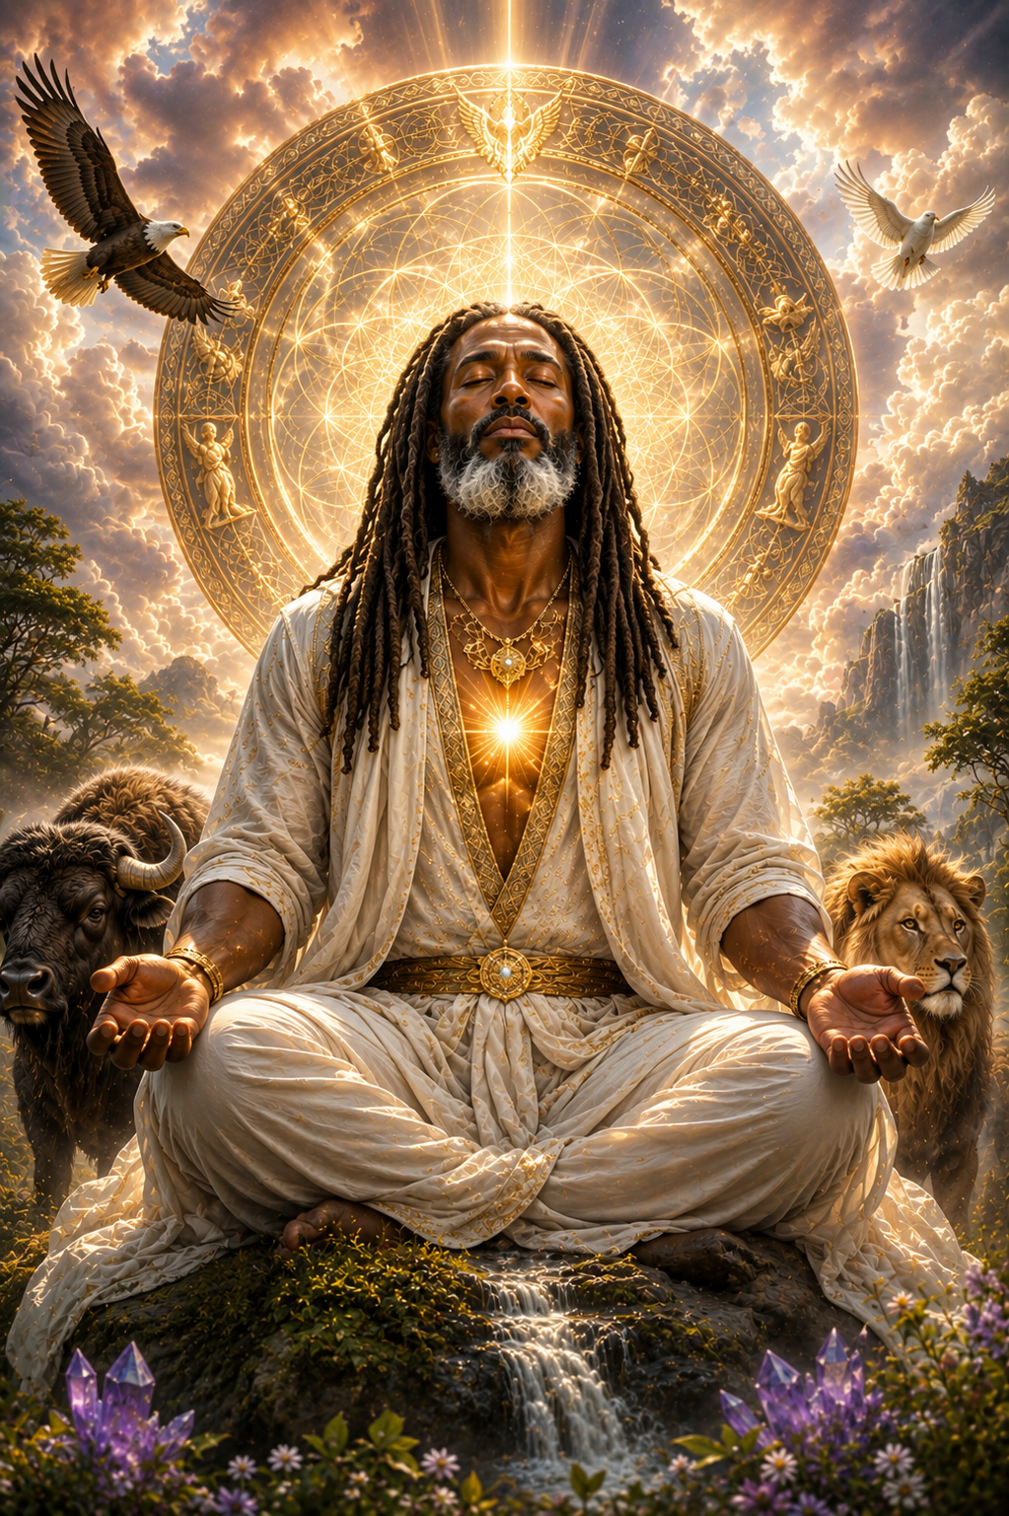

Table of Contents
An Author’s Note 3
In The Morning Prayers 4
Healing Through My “I AM Presence” 5
“The Great I AM Is My Healer” 6
Immortal Power of Cosmic Christ Love 6
As I Fall Asleep Tonight 7

An Author’s Note
How I Pray to the Great “I AM” — My Daily Spiritual Practice.
To my Brothers, and Sisters of the light, I wanted to share something a little more personal today. Rather than simply giving you another prayer, I want to show you how I use these prayers in my own daily life.
In the morning, I begin by sending Love to my Mighty “I AM Presence.” I call forth the Pearlescent White Flame, surround myself with the Electronic Circle and Tube of Pure White Light, and open my Heart Flame to the Presence of God within me.
When I am ready for meditation, I place my hands over my heart, breathe the frequency of my “I AM Presence” into my Heart Flame, and enter inwardly into the Cave of Creation. There I become quiet and receptive, allowing the Love, Light, and Healing Power of the Great “I AM” to work within me.
During the day, I may call forth the Resurrection Flame or the Immortal Power and Immortal Purity of Cosmic Christ Love, according to what I feel I need.
And before sleep, I again send Love to my Mighty “I AM Presence,” asking that the Healing Flame continue Its work within me while my physical body rests.
I share this not as a rule for how anyone else must pray, but simply as an example of how I have learned to make prayer, meditation, and communion with the Great “I AM” part of my everyday life.
Perhaps something from my practice will inspire you to go within your own heart and discover the way that brings you closer to the Presence of God within.
“I AM That I AM.”
With Divine Love,
Maurice

In The Morning Prayers
Call Forth My Pearlescent White Flame
Upon awakening, I send Love to my Mighty “I AM Presence” and to my “I AM Christ Self.” I demand the action of my Pearlescent White Flame of Purity, Love, and Innocence, as it is the spark of God’s Living Light, to charge everything in my world this day with Love.
I call forth my Electronic Circle to descend around me. I see my “I AM Presence” enclosing me in His Electromagnetic Field of Pure White Light, expanding within and around me as a mighty Tube of White Light that protects and nourishes me.
“All information and energy exchanged here today is according to God’s Will.”
From the center of my chest, a brilliant White Light expands, brighter than the sun. This Light burns not in a physical way, but in the Spirit, transmuting all negativity into the Living White Light of God.
I invoke my “I AM Presence” and my Staff of Life to purify my pineal gland so that it functions as it is meant to. I now call forth my Mighty “I AM Presence” and my Electronic Circle, which forever pour forth the blessings of my Love in action, to heal everywhere this Love moves and all whom I contact.
With my open Heart Flame, I call forth the Unfed Flame to expand upward into the Sevenfold Flame of the Seven Mighty Elohim within my forehead. I call upon Master Jesus and Lord Sarah to merge their vibrations into my auric field, allowing my Higher Self to merge with their Divine Essence.
I now receive a great infusion of Sacred Fire and Purifying Love from the Pearlescent White Flame, flowing into my Electronic Circle and blessing all under this Radiation, charged with the Sacred Fire of Master Jesus and Lord Sarah.
I am being healed in this very moment—in this space and time—on every level of my being, releasing all soul blockages, transmuting and transforming them within the Pearlescent White Flame, the Living Light of God that never fails to heal.
And so, it is. Amen.

Healing Through My “I AM Presence”
In the name of “I AM That I AM.” “I AM That I AM.” “I AM That I AM.” From the Lord God of my being, I now call forth a great infusion of my Mighty “I AM Presence” into every aspect of my being, into every cell, every atom, every electron, and every fiber of my physical, mental, emotional, and etheric bodies. I place my hands over my heart, and I breathe the frequency of my “I AM Presence” into my Heart Flame. As I enter into the Cave of Creation for my meditation, I open my heart to receive the Love, Light, and Healing Power of the Great “I AM.”
Mighty “I AM Presence” within me, come forth into action now. Fill my body with Your Divine Healing Love. Fill every cell, organ, tissue, and system of my body with Your living Presence. Let Your Healing Light flow throughout my entire being, restoring harmony, balance, wholeness, and Divine Perfection.
I acknowledge that the Great “I AM” is not outside of me. The Presence of God lives within me. I call forth that Divine Presence now and allow Its Healing Power to move through every aspect of my being that is in need of healing.
“I AM the Resurrection and the Life.”
“I AM the Resurrection and the Life.”
“I AM the Resurrection and the Life.”
Through my Mighty “I AM Presence,” I call forth the Resurrection Flame to resurrect Divine Life, Divine Love, Divine Harmony, and Divine Wholeness throughout my being. I breathe the Great “I AM” into my heart. I receive It. I live It. I embody It.
“I AM” one with my Mighty “I AM Presence,” and my Mighty “I AM Presence” is one with me.
The Love of God surrounds me, the Power of God protects me, the Presence of God watches over me, wherever I AM, God is, and all is well. “I AM That I AM.” “I AM That I AM.”
“I AM That I AM.” And so, it is.

“The Great I AM Is My Healer”
I open my Heart Flame to you, and send my love to my Beloved Mighty “I AM Presence,” “I AM That I AM,” “I AM That I AM,” “I AM That I AM.”
Great “I AM” within me you are my Healer. Ignite the Resurrection Flame within my Heart Flame. Let Your Divine Healing Presence flow through my heart, my mind, my body, and every part of my being.
Resurrect within me Divine Health, Harmony, Wholeness, and Peace. I receive Your Presence, I receive Your Resurrection Flame, I trust Your Love. I allow the Great “I AM” to heal me now.
I AM That I AM. And so, it is.

Immortal Power of Cosmic Christ Love
“I AM That I AM.” “I AM That I AM.” “I AM That I AM.” Beloved Mighty “I AM Presence,” I open my heart to You now. I call forth the Immortal Power and Immortal Purity of Cosmic Christ Love into my heart and throughout my entire being.
Let the Healing Flame of Cosmic Christ Love take Command within me now. Let It flow through every cell, every atom, every organ, and every part of my being, dissolving all discord into Love and restoring Divine Purity, Harmony, Peace, and Wholeness.
I open my heart, I breathe It in, I receive It, and I allow Divine Love to do Its perfect work within me.
I AM the Immortal Power and Immortal Purity of Cosmic Christ Love in action within me now. And so, it is. Almighty I AM.

As I Fall Asleep Tonight
As I fall asleep tonight, I send my Love to my Mighty “I AM Presence” and ask my Mighty “I AM Presence” to charge my body with the Immortal Power and Immortal Purity of Cosmic Love. I receive It. I accept It. I allow the Healing Flame to come into action within me now.
While my body sleeps, Mighty “I AM Presence,” pour Your Healing Love through every cell, every atom, every electron, every organ, and every part of my being. Let the Immortal Power of Cosmic Love restore harmony, balance, purity, and wholeness throughout my physical, mental, emotional, and etheric bodies.
Let the Healing Flame take Command, dissolving all discord and transforming everything that is less than Divine Perfection into the Living Light and Love of God.
As I sleep, I rest within the Love and Protection of my Mighty “I AM Presence.” I surrender myself completely to Its Divine Intelligence, knowing that It knows exactly what is required for my highest good.
Mighty “I AM Presence,” charge me, heal me, strengthen me, and renew my body while I sleep. Let me awaken refreshed, restored, and filled with Your Living Light and Love.
“I AM” one with my Mighty “I AM Presence.” “I AM” one with the Immortal Power and Immortal Purity of Cosmic Love. “I AM” receiving the Healing Flame now. And so, it is. Almighty “I AM.”

