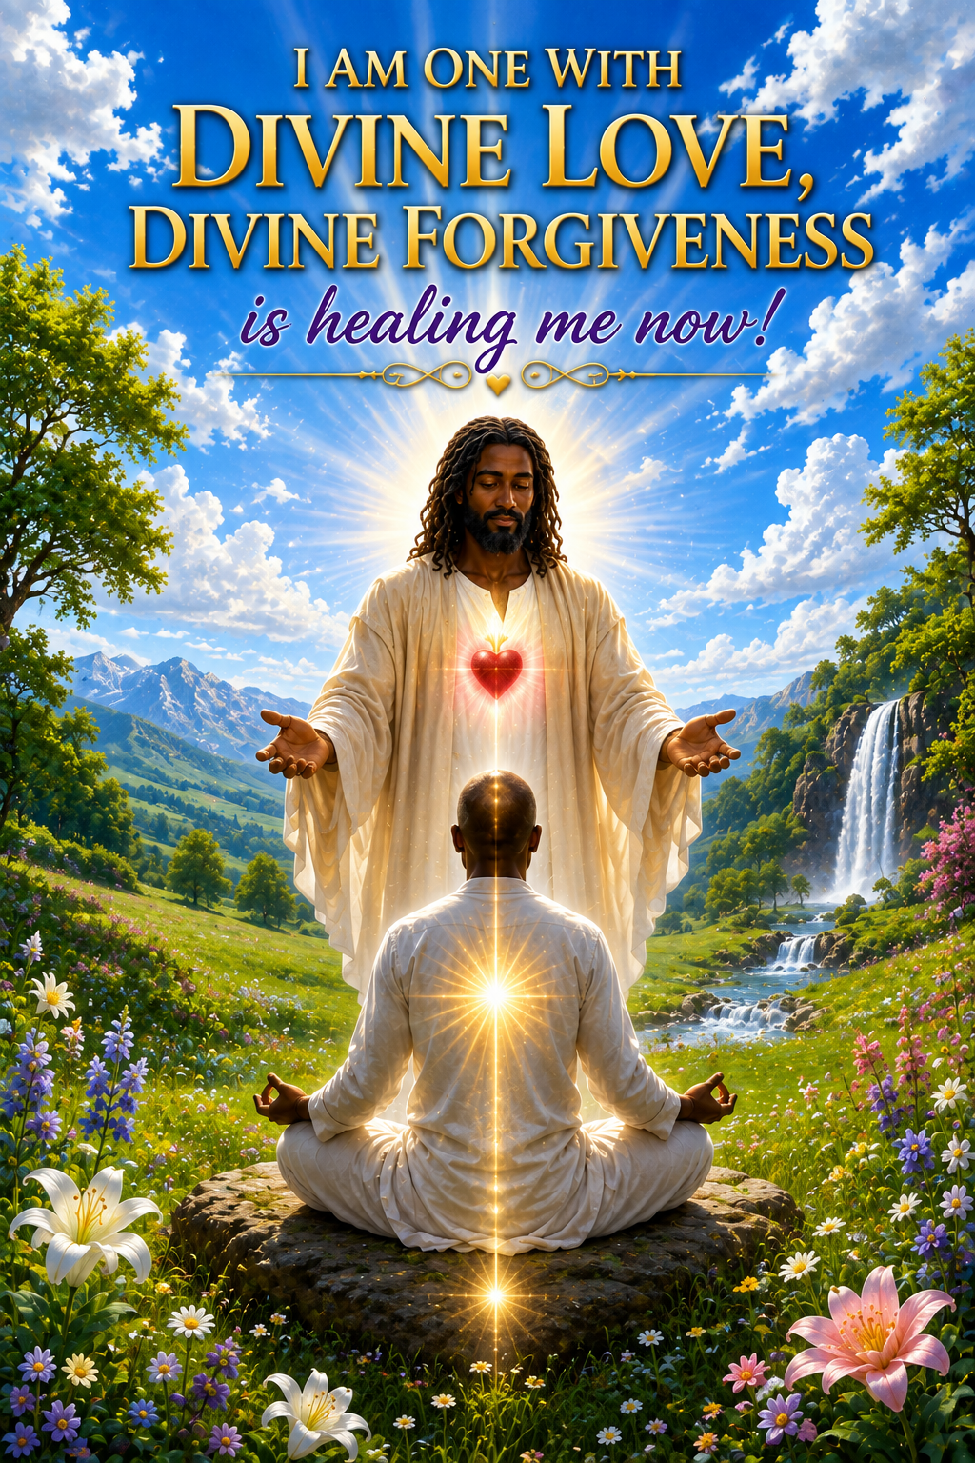

THE POWER OF UNCONDITIONAL LOVE
Divine Forgiveness, Karma, Healing,
and the Love Vibration.
Love is one of the most powerful vibrations we can bring into our lives. I am not speaking only about the love we have for our husband, wife, children, family, or friends. I am speaking about unconditional love—the Divine Love that comes from God and lives within the heart. This love does not ask what another person can give us in return. It does not disappear because someone has disappointed us, judged us, or hurt us. Unconditional love is a vibration, and when we consciously open our hearts to this vibration, it can begin changing the way we see ourselves, the way we see others, and the way we respond to the experiences of our lives.
Imagine yourself surrounded now by a beautiful Golden energy and Light of Divine Love. Take a gentle breath and allow this Golden Light to enter your heart. Breathe it into your body and allow yourself to feel the peace, warmth, and love surrounding you. As you breathe, allow this energy to fill your physical body and move through every part of your being. Do not force it. Simply open your heart and receive. Allow yourself to become illuminated and filled with Divine Love. Feel this love washing over you and moving through you, cleansing and raising your vibration. Know within your heart: I AM one with Divine Love. I AM one with Divine Forgiveness. I AM one with the Divine Light of God.

Divine Forgiveness Is Unconditional Love
Forgiveness is one of the greatest expressions of unconditional love. When we truly forgive, we are not saying that another person's actions were right. We are not pretending that we were never hurt, nor are we required to allow someone to continue mistreating us. Forgiveness means that we make a conscious decision to release the anger, resentment, guilt, blame, fear, and judgment that we have been carrying within ourselves. We choose to release these energies because they no longer belong within the vibration in which we desire to live.
Master Jesus taught forgiveness, and I have come to understand forgiveness as part of the vibration of unconditional love. It is easy to love someone who loves us. The greater lesson comes when we have been hurt and still choose not to allow hatred to enter and remain within our hearts. This does not make us weak. It takes spiritual strength to forgive. It takes strength to release judgment and place another soul into the hands of God. When we forgive, we are not only releasing another person; we are releasing ourselves.
Forgiveness must also include ourselves. There may be things we have done, consciously or unconsciously, that caused pain to another person. There may be words we wish we had never spoken or choices we would make differently today. We cannot go back and change yesterday, but we can change what we carry from yesterday. We can ask forgiveness, forgive ourselves, learn from the experience, and release it into the Divine Light of God.

Forgiveness and the Law of Karma
This is where forgiveness goes much deeper. Forgiveness is not only about what happened yesterday, last year, or even during this present lifetime. We are talking about karma carried lifetime after lifetime—experiences, wounds, vows, actions, and unresolved lessons that may have accumulated over time. These negative energies can build layer upon layer upon layer, and they are carried forward until the soul is ready to release them.
Karma is not punishment. Karma is memory. These layers represent experiences and energies that have not yet been completely released. This is one reason healing may not always happen immediately. We can pray. We can call upon Divine Light. We can sincerely desire healing. Yet there may still be layers that need to be peeled back and released before healing can fully take place.
Divine Forgiveness helps to release these karmic blockages. As we forgive others, forgive ourselves, ask forgiveness for anything we may have done consciously or unconsciously, and release guilt, resentment, fear, anger, blame, and judgment, we begin peeling away these layers of negative karma. One layer may release, and sometime later another layer may come forward. Then another. And another. This does not mean that forgiveness has failed. It means that we continue the process until what the soul is ready to release has been brought into the Divine Light.
This is why forgiveness should not be something we do once and then forget. Forgiveness is a sacred spiritual practice and a living frequency that we return to daily, just as medicine may be taken daily while the physical body is healing. We continue to forgive. We continue to release. We continue to open the heart. And as we do, the layers begin to peel away.

The Pearlescent White Flame
The Pearlescent White Flame is an important part of this process for me. The Pearlescent White Flame does not bypass karma. It helps peel away the layers of karma from the past into the present, allowing what is ready to be healed to come into the Divine Light of God. Some layers may release quickly, while others take time. Each layer releases according to the readiness of the soul and Divine timing.
The Pearlescent White Flame brings Divine Light into the heart and into those places where old energies have been carried. It does not judge what it finds. It does not force anything away. It allows these layers to soften, loosen, and dissolve as the soul becomes ready to let them go. This is why I believe healing unfolds rather than always happening at once. Layer by layer, what no longer needs to be carried is released into the White Light of the Divine.
As these karmic layers are peeled back, Divine Forgiveness becomes even more important. We may suddenly remember a person or situation we have not thought about for many years. An old emotion may rise unexpectedly. Rather than becoming upset because it has returned, we can recognize that perhaps another layer has come forward to be healed. We forgive. We release. We surround it with Divine Love and place it into the Pearlescent White Flame, trusting the Divine process.

The Love Vibration
Forgiveness and unconditional love work together. Forgiveness helps release the old vibration, while love fills the space that has been opened within the heart. As anger, resentment, guilt, fear, and judgment are released, we do not want to fill that space again with the same energies. We consciously fill ourselves with Divine Love.
Bring into your awareness someone you may have hurt, consciously or unconsciously. It may also be someone who has hurt you. Allow this person to come gently into your awareness while you remain surrounded by the Golden Light of Divine Love. Do not judge the person or the situation. Simply open your heart and allow the Love Vibration to move through you:
I love you. I'm sorry for anything I may have done, consciously or unconsciously, to hurt you. Please forgive me. Thank you, I love you.
Feel these words. Do not simply say them from the mind. Allow them to come from the heart. Feel the vibration of love and forgiveness moving through your being. You may repeat the Love Vibration three times, slowly and consciously, allowing yourself to experience what is taking place within you.
Then gently repeat: Forgiveness, forgiveness, Divine Forgiveness. Forgiveness, forgiveness, Divine Forgiveness. Continue for five or ten minutes if you feel guided to do so. Allow the vibration to work within you. Allow whatever needs to come forward to come forward, without judgment. Release it into the Light.

Love Yourself Enough to Forgive Yourself
Sometimes the person who is most difficult for us to forgive is ourselves. We may have forgiven everyone around us and still carry guilt over something that happened many years ago. But unconditional love must include us too. We cannot continually ask God to fill us with Divine Love while believing that we ourselves are unworthy of receiving it.
Look honestly at your mistakes, but do not make those mistakes your identity. Learn from them. If you can make something right, make it right. If you need to ask forgiveness, ask forgiveness. Then allow yourself to release the burden. You are not the same person you were ten, twenty, thirty, or fifty years ago. Every experience has given you an opportunity to learn and grow.
Say within your heart: I forgive myself. I release guilt, blame, fear, anger, resentment, and judgment. I release the negative karma that I am now ready to release into the Divine Light of God. I open my heart to Divine Forgiveness. I open my heart to unconditional love. I allow myself to heal.

Living Within the Vibration of Love
Each day gives us another opportunity to choose the vibration in which we want to live. When someone makes us angry, we have a choice. When someone judges us, we have a choice. When an old memory returns, we have a choice. We can continue feeding the old energy, or we can bring it into Divine Forgiveness and unconditional love.
Ask yourself: What would love have me do? Sometimes love will tell you to forgive. Sometimes love will tell you to remain silent. Sometimes love will tell you to speak the truth. Sometimes love will tell you to establish a boundary and walk away. Unconditional love does not mean allowing another person to control or mistreat you. Divine Love also contains Divine Wisdom.
Imagine what would happen if each of us began consciously sending more love into our homes, our families, our communities, and throughout Mother Earth. We cannot personally change every condition in the world, but we can change what we contribute to the world. We can stop sending hatred back into hatred. We can stop allowing yesterday's wounds to create tomorrow's wounds. We can begin breaking the old patterns through forgiveness and love.
As more of us awaken to unconditional love, we begin creating something different within the consciousness of humanity. We do not have to belong to the same religion, have the same skin color, come from the same culture, or understand God in exactly the same way. We are still part of one human family. The Divine Light is not diminished because another person walks a different path.

Divine Forgiveness and Love Practice
Become quiet and open your heart. Ground your energy into Mother Gaia and feel your connection with all life. Imagine the Pearlescent White Flame surrounding you and moving gently through your being. Allow the Golden Light of Divine Love to enter your heart. Do not struggle with what comes forward. Simply allow the Divine Light to reveal what is ready to be released.
Affirm slowly: I AM one with the Divine. I AM one with Divine Healing. I AM one with Divine Forgiveness. I AM one with Divine Love. I AM one with all of Life.
Feel these words within your heart. Allow the Light to move through you. If a person, memory, feeling, or experience comes into your awareness, surround it with Divine Love. Forgive. Ask forgiveness. Release it into the Pearlescent White Flame and allow another layer of negative karma to be peeled away and returned to the Divine Light.
Then enter into the Love Vibration: I love you. I'm sorry for anything I may have done, consciously or unconsciously, to hurt you. Please forgive me. Thank you, I love you. Repeat three times.
Allow yourself to feel it: Forgiveness, forgiveness, Divine Forgiveness. Sing it like a song, for about five minutes. Forgiveness, forgiveness, Divine Forgiveness. Forgiveness, forgiveness, Divine Forgiveness.
Let the vibration move through you. Let love fill the places that forgiveness has opened. Layer upon layer upon layer, release what you no longer need to carry.

The Power of Unconditional Love
Love is not merely something we say. Love is a vibration we learn to live within. Divine Forgiveness helps release the burdens of the past. The Pearlescent White Flame helps peel away the layers of negative karma that the soul is ready to release. The Love Vibration fills the heart with something greater than what has been released.
We forgive because we love. We ask forgiveness because we love. We forgive ourselves because we are learning to recognize that the Divine Love of God lives within us as well. And as the layers are peeled away, we become freer to express the spiritual being of Light that we truly are.
Allow Divine Forgiveness to become part of your daily life. Allow unconditional love to become the vibration of your heart. Trust the process of healing and Divine timing. What has been carried lifetime after lifetime does not have to be carried forever. When the soul is ready, another layer can be released. And then another. And then another.
Open your heart.
Allow yourself to receive, allow yourself to forgive, allow yourself to love, and allow the Divine Light of God to set you free.
I AM one with Divine Forgiveness. I AM one with Divine Love. I AM one with the Light of God.
Maurice Ramsey
Minister of the Light

