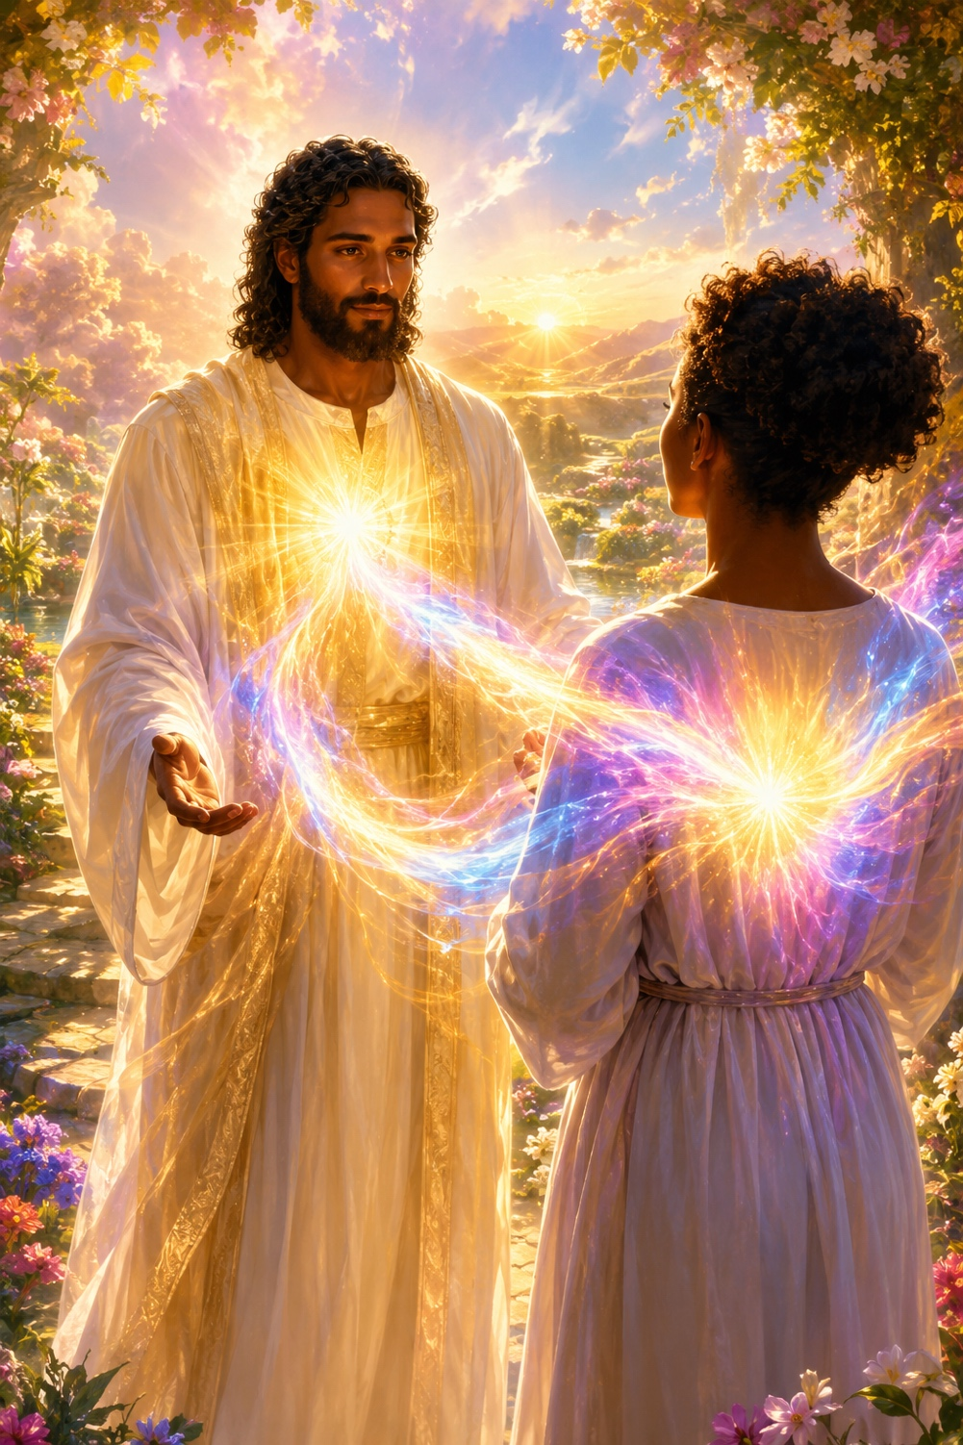
I AM the Resurrection Flame
of Lord Jesus
Lord Jesus, Channeled through Natalie Glasson
A Spiritual Teaching on Christ Consciousness,
Healing, Rebirth, and Service

Maurice Gains His Christ Consciousness
Greetings, Maurice. I AM Master Jesus. It is such a delight to connect with your heart energy. I wish to send, from my heart energy, the next level of Christ Consciousness Light for you to accept, raising the vibration of your Christ Consciousness Light to a new level.
A golden spear of Light extends from my heart chakra, and I send my love into your heart chakra now. Allow yourself to receive this spear of golden Light within your heart. Allow your soul to embrace this new energy and let the energies merge as one. Let the vibration of Christ Consciousness radiate and flow throughout your being, opening and developing your heart chakra.
Melting Your Mind into Your Heart
It is now most important to allow your mind to melt into your heart chakra during meditation. Maurice, simply allow yourself to enter a deep meditative state. Then ask for your mind to melt into your heart chakra, and allow yourself to inhale and exhale through your heart.
This will assist you in dissolving unneeded thoughts, gaining greater clarity, and healing the mind more fully. It is especially helpful for releasing beliefs that say you are not worthy or that you cannot trust your own abilities. In this state, the love of your heart and soul can enter your mind, cleanse your physical being and aura, and assist the expansion of your heart chakra.
There is much for us to achieve together. We shall work with the Resurrection Flame, and I will assist you in continuing to enhance the Christ Consciousness energy within you, allowing it to be expressed from your soul and heart. Many people upon the Earth are waiting for wisdom from the cosmic source of Christ Consciousness and for someone to express this energy as healing across the Earth and throughout humanity.
Connecting with Your Christ Consciousness
Maurice, I believe you are this individual. Connect with the concentrated energy of Christ Consciousness at a cosmic level. Imagine, sense, or acknowledge this Light flowing down through your chakra column and into the Earth, collecting at your heart chakra until you feel immense love, compassion, and purity building within your heart.
Let this energy flow through your physical body and aura. When you feel it is appropriate, allow it to be expressed through your heart chakra and the chakras in the palms of your hands. If possible, place your hands upon the floor or the Earth. If not, simply allow your palms to face the sky and hold the intention that this energy flows into the Earth, into humanity, and to the souls who have been waiting for this activation.
You will be imparting wisdom and consciousness from cosmic Christ Consciousness to inspire and activate the energies of others upon the Earth. You do not necessarily need to understand this wisdom as it flows through you; simply hold the intention of expression and giving. The more you practice, the more Christ Consciousness will also teach you as you allow yourself to be of service. This practice will serve the Creator and humanity while supporting your soul's development and growth.
There is much for you to achieve upon the Earth and many whom you will teach. I wish to share a meditation that will allow you to become your spiritual-teacher self and gather wisdom from within so that you may share it with others.
Focus on Your Heart and Soul
Maurice, allow yourself to be peaceful and to lie down. Focus your attention upon your heart chakra and soul. As you inhale, recognize and acknowledge the Light within you; as you exhale, allow your body to relax more deeply. Continue this practice for as long as needed, until your physical body becomes so relaxed that your only focus is your soul.
As you breathe deeply, continue acknowledging your soul and relaxing into its expansive Light. Remain within the sanctuary of your soul, with its wisdom, insights, and high vibrations swirling around and within you. In this state, you may ask questions of your soul and ask for abilities, skills, qualities, vibrations, or memories to come forward. Whatever you wish to understand in your physical reality, ask your soul to demonstrate or reveal it within this sacred chamber.
Working with Your Spiritual Teacher
It is your time to explore and to call forth your spiritual-teacher self. When you wish to return to your physical awareness, become conscious of your surroundings and your body. Ask for all the wisdom, insights, energies, and abilities you acknowledged within your soul to be anchored deeply into your physical body, even at the cellular level, so you may use them in your physical reality and become a greater expression of your soul.
Send your energies into the Earth to ground and center your being. This meditation will assist you in discovering much about yourself. There are many energies you can gather and bring forward to share with others as a healing or inspirational process.
There is also a need for you to speak from your heart chakra and soul more fully and easily. Sit before a mirror and acknowledge your reflection. Then close your eyes, enter a deep meditative state, and place the attention of your mind upon your heart chakra and soul.
Ask to speak to yourself from your heart, addressing your reflection even while your eyes remain closed. This will help you heal yourself and develop the ability to speak from your heart and soul to friends, loved ones, and those you wish to inspire and enlighten. Practicing this for ten minutes each day will act as a guiding Light, helping you follow your true path and recognize information and guidance.
Each day, call forth the Ascended Masters to wash your body and aura in their purity and love. This will help dissolve blockages and assist your physical body in attuning to your heart and soul. It may also ease stress and strain while supporting the health of your physical body.
As you practice, imagine yourself existing within pure white and golden Light. This is the space of Ascended Master Consciousness, where your own Ascended Master Consciousness can develop.
Maurice, also observe your mind frequently and acknowledge fearful or unneeded thoughts, then set them free. You can dissolve these thoughts in the Violet Flame of Light and ask the angels to shower you with love. If a thought returns through habit of the ego, simply brush it aside, knowing that you have released it and that it no longer holds control over you.
Through this practice, you will begin to develop a limitless view of reality in which all things are possible. Through the power of your mind, you can ask and create as long as it is the Divine Will of the Creator and your soul. You can call upon me and ask me to inspire you to view your reality in a new and limitless way.
The Resurrection Flame
Maurice, as I came forward, I took this opportunity to offer many practices to aid your spiritual growth. Now I come to the main purpose of this communication: I know you wish to understand the Resurrection Flame and use it more fully in your life.
The Resurrection Flame is a creative energy. It can be molded by the intention of the mind and can carry the pure intentions of the heart expressed through the mind. It may be seen as a tiny flame in the palm chakra or as a large, expansive flame surrounding the entire Earth.
It is a multicolored flame because it holds the essence, qualities, and energy vibrations of the Creator. Essentially, it is the Light of the Creator. The Resurrection Flame carries the purposes of connection, purification, and cleansing. It connects one's energy with the Creator's Light and helps one understand the transition between physical and spiritual being and reality.
When we sit within the Resurrection Flame, we can gain a balance that allows us to see physical and spiritual reality as one. They are no longer separate but integrated as one energy. It is as though the veil between dimensions dissolves, allowing physical reality to be influenced more strongly by the higher-vibrational energies of the Creator.
Within the Resurrection Flame, you may perceive the spiritual planes and other dimensions with greater ease. You may see beyond fear, suffering, and limitation and perceive the greater plan. With clear intention, you may understand how energy, situations, and moods can be transformed through higher vibrations.
The Resurrection Flame also helps false beliefs and illusions fall away. It is like a rebirth, a new beginning, or a new start. It allows unneeded energies and old cycles to be completed and released. It then polishes, enhances, and develops newly discovered energies so they can shine more brightly within your being.
We can see the Resurrection Flame as washing away dirt from a mirror. The dust represents earthly limitations and illusions. Once the mirror is clean, you can see with greater clarity and understanding, look beyond the pain of others, connect more deeply with the Creator's Light, rejuvenate your being, and enter the next stage of your spiritual growth.
Practicing with the Resurrection Flame
Each day, sit within the Resurrection Flame. You may ask me, Master Jesus, to anchor it, and I advise sitting within it for ten minutes while breathing in its energies. Know that it is transforming your being, releasing the past and old cycles, developing new energies, and dissolving the sense of separation between earthly and spiritual reality within you.
You no longer need to see yourself merely as a physical person walking a spiritual path. You are your spiritual path, and you are the physical being. These energies are one within you, and this integration is immensely healing.
Practice for ten minutes a day for five days. You may practice twice a day if you feel it is appropriate. Then allow yourself three days of rest to notice any changes before practicing again for another five days.
After this deeper integration, you will be able to anchor the Resurrection Flame for others through simple intention while meditating with them and asking them to breathe deeply. You may then use the Flame whenever you wish or whenever you feel it is appropriate.
The Resurrection Flame is a helpful energy when you feel stuck or when things are not flowing as they should. Sit within it to connect more deeply with the Creator. In times of pain or suffering, it can help you remain balanced, see clearly, and avoid becoming lost in the illusions of the ego.
Creation and Manifestation
The Resurrection Flame also carries the energy of creation. You can sit within it and ask for something to manifest in your life, but always ask for the needed energies to arise from within you.
For example, if you desire healing or greater abundance, ask the Resurrection Flame to activate or resurrect the energy of healing or abundance within your being. Allow that energy to flow powerfully through your heart and manifest what is needed in your life. You may state the purpose you wish to accomplish.
This is a way of using the Resurrection Flame as a supporting energy for creation and manifestation. It resurrects or rebirths the energies already within you and brings them into physical reality. Maurice, everything is within you.
You have used the Resurrection Flame before upon the Earth, so in many ways you already understand how to work with it. I have also been tutoring you upon the inner planes, and much knowledge about the Resurrection Flame is held within your soul.
Healing with the Resurrection Flame
The Resurrection Flame may also be used in healing. If a person has pain, illness, or suffering in an area of the physical body, you may ask the Resurrection Flame to anchor into your hands. With the person's consent, hold the intention of bringing the Flame to the area in need of healing.
Ask the Flame to dissolve negativity, cleanse and purify the area, and resurrect or activate positive, loving energy within the cells, molecules, and energy particles. You may place within the Flame the intention of perfect, radiant health. The best way to work with it for yourself or others, however, is to sit within its energy.
With the consent of another person or group, you may anchor the Resurrection Flame around them as they sit within its energy. This can assist their spiritual growth and ascension process. This is how I wish for you to work with the Flame at this time.
The more you experience its energy, the more you will understand how to use it. It is a high vibration and can support profound change, especially when the user holds a pure, clear mind and strong intentions arising from the heart. The earlier practices I offered will assist your work with this Flame of Light.
As you work with the Resurrection Flame, its consciousness and energy become more deeply anchored within your soul and cellular level. In time, you may no longer need to consciously call it forth; it can flow naturally, as blood flows within the physical body. You may find that your thoughts are enhanced and that you can express, grow, and develop with greater ease.
Closing Guidance from Master Jesus
Maurice, always follow your heart and soul and remain true to yourself. Love yourself unconditionally and trust your own wisdom and guidance. Most importantly, allow limitations to flow away so you may exist as your truth and your God Presence.
Let your devotion to the Light continue, and know that we are here to support you. You have a vast and expansive group of Ascended Master beings waiting to guide you and work through you in service to others. Each day, surrender yourself to the Creator and your Ascended Master guides, allowing their energies to enter your being, transform you, guide you, and assist you. Simply breathe in our energies.
Maurice, I love you unconditionally and embrace you in my arms. We are one; we are brothers of the Light, and I AM here to honor you. Remember that everything you need to understand and acknowledge is within your soul. Always look within and trust.

