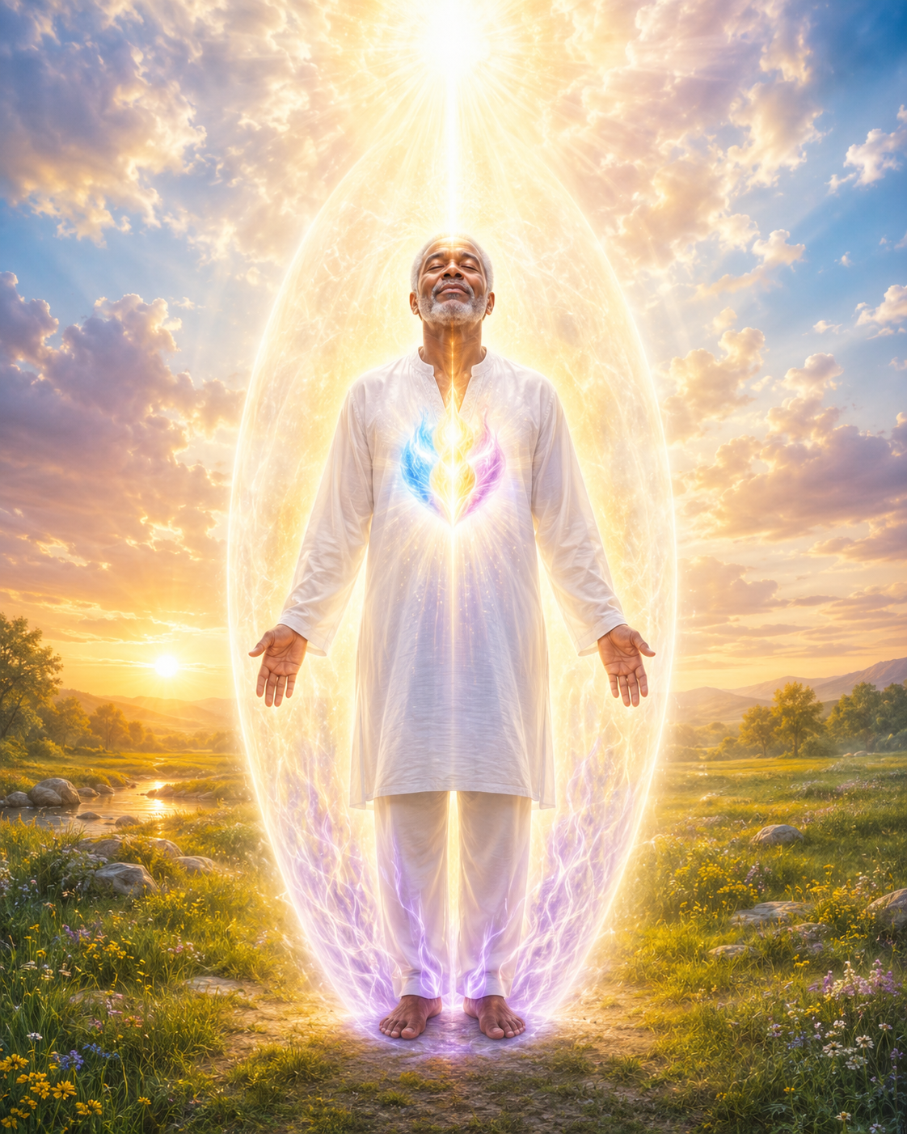
AWAKENING THE I AM PRESENCE WITHIN
The Living Presence of God Within You
Channel through Lea Chapin
March 14, 2026

Good morning, Maurice. I will begin. Father, Mother God, we call forth the highest frequency, the highest light for Maurice's soul growth.

As always, Father, surround us with your love, light, healing, wisdom, and truth as we invoke the energy of Master Jesus to step forward, to bring his words of wisdom, healing, and guidance to this beloved soul. And as always, Father, surround us with your Holy Protection and grace, and this we give our blessings, and so it is.

Greetings, Dear One. Yes, it is I, Christ. I come to you on this most auspicious day. It is an honor to be with you and to now be a part of your own energetic frequencies that you are bringing forth into your book. It is an honor to have my frequency and my energy present within you.

You are always deepening this connection with me through your intention, and it is again through these frequencies that you allow your heart to remain open and to remain pure. For as you call forth these frequencies, know that at each moment that you are standing in the eternal love of All-That-Is, you are standing in the eternal love of All-That-Is; you are standing in the eternal love of All-That-Is. As you invoke your own energy of your own “I AM Presence,” may you invoke the frequency within you.

Oh, loving “I AM Presence,” walk through me, open the door of understanding, so I may become increasingly aware of the perfection of my own divine perfection. As I assist in the love and the light for all people to awaken to their “I AM Presence,” as I'm growing in awareness, may you allow me, the consciousness, the wisdom, the love, to begin to awaken through my book, The loving “I AM Presence” of my own Christ Consciousness. Allow my sense of gratitude to expand into a welcoming and graciousness, and allow this realization that my I AM Presence will spread its radiant light to everyone I meet, to everyone who reads my book. 230

Thank you for the discovery that the consciousness of divine intelligence lives within each one. May the light of truth illuminate your mind and all minds as I, Christ, grow in a greater awareness into the hearts of all souls, as I place my hand upon you and others to simply begin to feel the energy of their owned “I AM Presence.” I say to you, the energy of light is victorious; that you are the light, you are the love, you are the Christ Consciousness.

Know that you are one with All-That-Is, and so, rejoice in this glorious truth, “I AM-that-I AM,” “I AM-That-I AM.” See yourself as a pulsating being of light reading through the flesh, rather than the flesh structure attempting somehow to invoke the Being of Light and draw through it, knowing that you are the Light, that your body is the Light, your mind is the Light. “I AM That I AM,” “I AM that I AM,” “I AM the Presence of the Living God inside me.”

This will simply set you free as you begin to teach and instruct others how to invoke the “I AM Presence” within them. Instantly, your consciousness is raised above the human mind, for you're not simply a human; you are the “I AM Presence” of the God Energy, and allow your consciousness to expand as you begin to place your attention once again on the awareness of your true identity. And say to yourself:

“I AM,” a force of God moving upon this planet. “I AM” an upward Radiating Ray, force of vibration and consciousness, which is my Heart Flame, the true center of my being. This flame is my electronic aura spreading around me. Cosmic energy flows through my aura.

“I AM” a Being of very Powerful Light, “I AM” one with all Light, the Great Universal Consciousness “I AM,” “I AM that I AM,” “I AM that I AM.”

In the name of the Mighty Presence of God within you, through the power of God blazing in every heart, through every Heart Flame, I, Christ, invoke the energy of the Resurrection Flame, and all of the Legions of Light associated with the Resurrection Flame, through infinity, through the power of love and light to come forth, spreading the energy of the Resurrection Flame into every cell, atom, and electron of your being, into the hearts and minds of all souls, and sending the Resurrection Flame to flood the earth, and allow her, or the earth, to begin to feel the Power of the Resurrection, just as you, in your human form, are feeling the Power of the Resurrection. As you come forth to set forth this victorious energy, for you are an instrument of God re-establishing the divinity wherever the Resurrection Flame is present. You, as an instrument of God, are re-establishing the divinity of the Resurrection Flame wherever, and wherever, and whoever shall receive it.

As you say to yourself: “I AM” the Flame of Resurrection in action. “I AM” a Director of the Resurrection Flame, and “I AM” Humble before its magnificent presence. I'm grateful to unleash the Power of the Resurrection Flame within me, and to all beings, and to establish it once again on the earth in its fullest form.

“I AM” an Instrument of God, charging the electronic substance through, around me, through the power and the might of the Resurrection Flame, invoking the Resurrection Flame into my own life, creating miracles and manifestations. “I AM” an Instrument of God, charging the electronic substance in and through and around all life, with the power and might of the Resurrection Flame, and the bridge over which it flows. I am its final effect of divinity established on earth.

“I AM that I AM,” “I AM that I AM.” I hold the Power of the Resurrection Flame within me. Victory is mine. Victory is mine. The victory is mine.

The perfect balance of my Father-Mother-God Presence has returned on earth, and my “I AM Presence” is awaiting the opportunity to take full dominion of my thoughts, words, actions, and feelings. With this inner knowing, I realize I have the awesome responsibility of becoming the full manifestation of my “I AM Presence” while I'm still embodied on earth. This literally means integrating your “I AM Presence” into all aspects of your being.

This integration is occurring now at an atomic cellular level. Every electron, every atom, every subatomic particle and wave of your own body and your own subtle light bodies and all aspects of your being are being re-established into the fifth-dimensional frequency of solar light. This integration allows your I AM Presence to take full dominion of your physical, etheric, mental, and emotional bodies.

As this occurs, your thoughts, words, feelings, and actions reflect the divine harmony and balance of God. This transformation is changing your physical reality into the infinite physical perfection of your I AM Presence. This is a grand opportunity to continue to ascend, to ascend in your I AM Presence.

And as you allow the energy of your own Ascension Flame, allow the Ascension Flame to come forth through the Power of the Ascension Flame, know that you are the power that you have been waiting for. You are the Power of the Ascension Flame; you're an instrument of God, you're an instrument of God, you're an instrument of God.

Knowing, again, that you are tapping into your own I AM Presence through this power, through this love, through this peace, and through this glory, you will continue to invoke the Ascension Flame within the essence of your being. As you invoke also the energy of the Violet Flame of Transmutation to the beloved Presence of God I AM, know, blazing in my heart, I invoke all the Legions of Light through affinity who are associated with the fifth-dimensional frequencies of the Violet Flame.

On behalf of yourself and all of humanity, know that your “I AM Presence” is now blazing and bringing forth this purity within your own soul at a frequency that is in harmony with the balance of the “I AM Presence” of your God essence. Beloveds, know that as you ask for this frequency of the Violet Flame to transmute within you, simply call forth. Transmute, transmute, transmute by the Violet Fire, all causes and cores, none of God's desire.

For you are a being of love, and love you shall remain. You are a being of light, and light you shall remain. You are a being of joy, and joy you shall remain.

As you continue to be an instrument of God, weaving your gifts, your talents, your skills, your knowledge, your strength, your courage, and compassion and love into the tapestry of the divine plan for the new earth and for yourself, to responding to your heart's call of your “I AM Presence”, that you're consecrating your thoughts, words, actions, and deeds to the greatest force of good, for you're an instrument of God, that you're making a positive difference every day in every way. Through the focus of your attention, you're expressing the divine truth. “I AM” one with all Life.

“I AM” Divine Love, “I AM” infinite abundance, “I AM” the harmony of my true being.

I'm vitally healthy and eternally youthful. I'm a peace-commanding presence. The actions I take every day improve my family, my job, my community, my city, my country, and the world.

I'm communing and knowing that “I AM” an Instrument of God. “I AM, that I AM,” “I AM that I AM.”

“I AM that I AM.” “I AM an Instrument of God. “I AM that I AM.”

That “I AM”, the embodied for this reason, and this is the reason for my Presence. This is the reason for my being. This is the reason of all life, and why I am here.

For yes, it is my decree. I accept it, and so, I decree it and accept it's done. “Beloved I AM.”

“Beloved I AM,” “Beloved I AM.” Let the light and the victorious energy of God be instilled within me, as I feel the presence of God's Living Light upon my soul.

And now, Dearest Son, know that I, Christ, am with you always. There's no reason to question. There's no reason to be afraid.

There's no reason to feel less than. You are the “Mighty I AM.” And as you use your words in writing your book to help others to renew and to restore the divine restoration of their own soul, to reclaim the flame of life within them, the Vital Life Force of the God essence, as you feel the energy of the Violent Flame transmuting all discordant energy within you, around you, through you, and upon the earth, may you truly feel the Love of God surround you.

May you truly feel the Power of God within you. May you truly feel the peace of God upon your own soul. “I AM that I AM.”

“I AM that I AM,” ‘I AM that I AM.” And so, as you call forth this power, trust and believe within yourself.

Know, dearest ones, there is Great Love within your heart, and there is nothing to be afraid of. You are in the Divine Presence of your own “I AM Presence.” And so, dearest ones, feel the joy, feel the peace, feel the comfort upon your own soul.

And so, dearest ones, know, feel the light as you share your book with others, as you share your peace with others, as you share your transformational light with others; you are changing the world. You truly are a divine vessel of All-that-Is. So, again, as I have said, never question yourself, never question yourself, never question yourself.

For you are the perfection of God. For know that your life is one in response instantly to divine love. Through your Heart Flame, your physical body is refined and filled with light.

Therefore, know that your Heart Flame expresses love, awakening to the voice of your “I AM Presence.” And know at this time that you are the divine child of great love and great peace. Be still, be still, be still, and know that you are loved.

Be still, be still, be still, and know that you are loved. Be still, be still, be still, and know that you are loved. Love beyond measure, love beyond comprehension.

Be still and know that you are loved. And so, dearest one, you will use these words and these teachings and my energy to write your book and to bring it out into the world. Again, calling in the Violent Flame to transmute, calling the Resurrection to call forth the energy of the “I AM Presence,” and to resurrect your true divinity for all souls to feel, to know, and to understand.

And so, be still and know that “I AM” God. Be still and know that “I AM” God. Be still and know that “I AM” God.

That you are God. We are God. All are God.

All are the divine essence of the Great Creator. And this you shall be at peace. Be still, be still, be still, and allow the light of my own Presence of the Christ Consciousness to work through you.

And there's nothing to worry, nothing to fear. Bring forth your teachings. It is all in the hands of God.

Go in peace. And we thank you, Christ. And for this, we are truly grateful.

And so, it is.

